HOSPITAL MANAGEMENT SYSTEM

- Introduction
1.1 Title of the project :
“HOSPITAL MANAGEMENT SYSTEM”

1.2 Purpose
This is a modern web-oriented application developed to streamline and automate the daily administrative and clinical operations of a healthcare facility. It provides a centralized platform that allows administrators to efficiently manage doctors, patients, appointments, and specialized medical services. Since medical professionals and organized workflows are the backbone of any healthcare institution, the Hospital Management System serves as an essential tool for enhancing hospital efficiency and patient care.
This system effectively oversees comprehensive hospital details, including doctor profiles, departmental specializations, consultation schedules, and patient records. The software also facilitates a seamless digital appointment booking process, enabling patients to schedule doctor visits or request specific medical services, which helps the administration track daily consultations and resource utilization.
The Hospital Management System is designed to be highly user-friendly and intuitive. Administrators can effortlessly manage doctor availability, oversee patient registrations, coordinate service appointments, and maintain the facility's overall workflow. By securely storing all critical information—such as user credentials, scheduling data, and service records— in a centralized database, the software eliminates manual paperwork, ensures data integrity, and prevents administrative miscalculations. Ultimately, it significantly improves the operational speed and reliability of the healthcare organization.

1.3 Scope
This software is comprehensive in handling all essential details regarding the hospital's daily operations. The details managed by the system include patient records, doctor profiles, medical services, and appointment schedules. Administrators can seamlessly view categorized reports based on doctor specializations or available departments. This software helps keep accurate track of all upcoming and past appointments, which enables the facility to organize hospital workflows and resource allocation efficiently. Furthermore, this system serves as a reliable tool to rapidly retrieve individual patient histories, doctor availability, and specific medical service details whenever required.

1.4 Overview
The “Hospital Management System” is an advanced web application that provides a
complete, secure, and efficient way to manage, maintain, and coordinate the vital operations of
a healthcare facility.

Login Process
- A streamlined and secure interface is provided for different user roles (e.g., Patients, Doctors, Administrators).
- Proper input validations and security protocols are strictly enforced at the time of user registration.
- Critical account registrations, such as adding new doctors or administrative personnel, are securely managed and approved by the core Admin team.
- Verified users are permitted to securely log in to their respective personalized dashboards using their registered credentials (username/email and password).

Modules:
The “Hospital Management System” consists of the following main modules:
- Admin Module
- Doctor Module
- Patient Module

Admin Module
- Login: This is the process in which the administrator securely logs into the system dashboard by providing valid administrative credentials.
- Add Doctor: Admin can onboard new medical professionals by adding necessary details such as the doctor's name, email, specialization, years of experience, and consultation fees.
- View Users & Doctors: Admin can view comprehensive records of all individuals registered in the system, including patient demographics and detailed doctor profiles.
- Manage Appointments: Admin can oversee, approve, or cancel doctor consultation appointments requested by patients to maintain an organized and balanced hospital schedule.
- Manage Services: Admin can add, update, or remove specialized medical services, treatments, or diagnostic tests offered by the healthcare facility.
- View Service Appointments: Admin can seamlessly track and manage bookings specifically made by patients for these specialized medical services.
- Dashboard Analytics: Admin has access to an overarching view of hospital metrics, allowing them to track the total number of active doctors, registered patients, and overall appointment volumes.
- Doctor Schedules: This involves managing and monitoring the daily availability and consultation timings of doctors within the hospital.
- Manage Fees & Billing: Admin can oversee the consultation fees structured by the hospital and track general financial summaries related to patient bookings.
- View Booking History: Admin can access a detailed history of past appointments, allowing the hospital to keep track of completed consultations and service utilization.
- Search: Admin can utilize search filters to quickly retrieve specific patient medical records, doctor information, or appointment details from the centralized database.

Doctor Module
- Login: This is the process in which doctors securely log into their dedicated portal by providing valid credentials assigned by the administration.
- Update Profile: Doctors can manage their professional profile by updating details such as their specialization, experience, and consultation fees.
- Manage Schedule: Doctors can set their available timings, manage their daily consultation schedules, and update their availability status for patient bookings.
- View Appointments: Doctors can view a comprehensive list of their daily patient appointments, including pending, upcoming, and completed consultations.
- Patient Records: Doctors are allowed to access the medical histories of their assigned patients and add consultation notes or prescriptions.
- Earnings Summary: Doctors can view a summary of their consultation fees and track their overall earnings generated through patient bookings within the system.

Patient Module
- Registration: Patients are allowed to securely register for an account by providing valid personal and contact information.
- Login: This is the process in which patients log into their personalized user dashboard using their registered email and password.
- Book Doctor Appointments: Patients can search for medical professionals based on their specialization and book consultation appointments according to the doctor's availability.
- Book Medical Services: Patients can browse and book specific medical services or diagnostic tests offered by the healthcare facility.
- View Appointment Status: Patients can track and view the status of their requested appointments (e.g., pending approval, confirmed, or cancelled).
- Update Profile: Patients are allowed to manage their account by updating their demographic details or contact information.
- Medical History: Patients can view a record of their past appointments, consultation details, and any medical advice or prescriptions provided by the doctors.

Software Requirements:
- Operating System: Windows, macOS, or Linux
- Runtime Environment: Node.js
- Database: MongoDB (Local or Cloud-based)
- Frontend Framework: React.js
- Backend Framework: Express.js
- Web Browser: Google Chrome, Mozilla Firefox, or Microsoft Edge Hardware Requirements:
- Processor: Intel Core i3 / AMD Ryzen 3 equivalent or higher
- RAM: 4 GB RAM or more
- Storage: 10 GB Hard disk space or more
- Internet: Active internet connection (required for API communications and cloud database access)

1.5 Objectives
The main goal of developing a Hospital Management System is to provide an easy and efficient way to automate all critical hospital operations, which includes managing patient registrations, doctor schedules, and appointment bookings seamlessly.

Existing System
Presently, in many traditional setups, patient registration, appointment scheduling, and medical record-keeping are done manually using physical registers. This manual work takes a significant amount of time, often leading to long waiting queues for patients. Due to the manual coordination process, managing schedules between multiple doctors and patients becomes highly error-prone, occasionally leading to double-booked time slots or delayed consultations. This presents an enormous problem to hospital administration, especially when quick access to a patient's medical history or urgent appointment scheduling is required in a timely manner.

Disadvantages
- Maintenance of patient records, appointment logs, and doctor schedules is complicated and highly time-consuming.
- Physical patient files, registers, and record cabinets occupy a vast amount of physical space within the healthcare facility.
- The system involves an extensive amount of daily paperwork for both the reception staff and the medical professionals.
- Crucial medical documents, prescriptions, and patient histories may be easily misplaced or permanently lost.
- Searching for a specific patient's history or maintaining and updating medical records manually is complicated and severely delays the overall delivery of medical services.

Proposed System
The proposed web application will effectively resolve all the administrative, scheduling, and data management problems the hospital is currently facing. This software is designed in such a way that it streamlines the entire appointment booking process, from initial patient registration to the final consultation. Consequently, it eliminates the worries associated with overlapping schedules or misplaced medical histories. This software helps keep accurate track of each doctor's availability, daily appointments, and patient interactions, ensuring a smooth and highly efficient operational flow within the healthcare facility.

Major advantages of the proposed system over the existing manual system are:
- Efficient time management and hospital resource allocation
- Rapid processing of patient information and medical records
- Significant reduction in physical paperwork
- Fast and reliable distribution of schedules and appointment updates
- Reduction of administrative overhead costs
- Enhanced security and strict protection of sensitive medical data

2. SYSTEM ANALYSIS :

System analysis is a foundational phase in the software development lifecycle that involves a thorough examination of existing practices, identification of limitations, and the formulation of requirements for a more effective automated solution. In the context of the Medi-Flow project, this phase focused on understanding how healthcare appointment management is currently handled and where significant inefficiencies exist.
The primary objective of this analysis was to evaluate the shortcomings of traditional and manual methods of booking medical appointments and accessing healthcare services. In most conventional setups, patients are required to physically visit a clinic or hospital to schedule an appointment, often resulting in long waiting times, scheduling conflicts, and limited visibility into doctor availability. Similarly, healthcare service providers lack an organized mechanism to efficiently manage appointments, reschedule them, and track payment status in real time.
To address these challenges, a detailed study of the existing workflow was conducted. Data was gathered regarding the typical patient journey — from identifying a suitable doctor or medical service, to booking an appointment, making a payment, and tracking appointment status.

2.1 Problem Statement
In the traditional approach to healthcare appointment management, most processes are carried out manually and are heavily dependent on paper-based records or static phone-based bookings. Clinic staff are required to maintain physical registers or spreadsheets to log patient details, doctor schedules, and appointment records on a daily basis. This manual method is not only time-consuming but also prone to human error, data duplication, and the risk of record loss.

2.2 Feasibility Study
A feasibility study determines whether a proposed system is practical and achievable. The MediFlow project was evaluated across three key areas:
Operational Feasibility The system is easy to use for all three user types — patients, doctors, and administrators. Being web-based, it requires no special hardware or installation. It works on any browser and supports all screen sizes.
Technical Feasibility Medi-Flow is built using modern and widely-used technologies — React.js for the frontend and admin panel, Node.js with Express for the backend, MongoDB for the database, Clerk for authentication, Cloudinary for image storage, and Stripe for payment processing. All tools are well-documented and within the team's capability.
Implementation Feasibility The project is divided into three independent modules — frontend, admin panel, and backend — making development and testing easier. Since it uses cloud-based services, no physical server is required, making deployment simple and cost-effective within the project timeline.

2.2.1 Economic Feasibility
Economic feasibility checks whether the benefits of the system justify its cost of development.
Medi-Flow was developed as part of an academic project, so there is no commercial cost involved in its creation. The technologies used — React.js, Node.js, MongoDB, and other supporting services — are either free or available in free-tier plans suitable for development and demonstration purposes. By replacing manual paper-based processes with a digital system, the application reduces administrative effort, saves time, and minimizes chances of data loss or errors. Therefore, the Medi-Flow project is economically feasible.

2.2.2 Operational Feasibility
Operational feasibility determines whether the proposed system will be practically usable and accepted by its users after deployment.
Medi-Flow is a user-friendly web application that can be operated by anyone with basic internet and browser knowledge — no advanced technical skills are required. The interface is clean, intuitive, and guided, making it easy for patients to browse doctors and book appointments, for doctors to manage their profiles and schedules, and for administrators to oversee the entire system. The application is designed to handle common user actions smoothly and display appropriate messages to avoid confusion. Therefore, the system is operationally feasible and ready for real-world use.

2.2.3 Technical Feasibility:
Technical feasibility checks whether the available tools and technologies are sufficient to build and run the proposed system.
Medi-Flow is developed using the following technologies:
- React.js (Vite) — for building the patient-facing frontend and doctor panel
- Node.js with Express.js — for the backend server and REST API
- MongoDB with Mongoose — as the database for storing doctors, appointments, and services
- Clerk — for secure user authentication and role-based access
- Cloudinary — for uploading and managing doctor and service images
- Stripe — for handling online payment processing and payment status tracking
- JWT — for secure token-based communication between services
All of these technologies are free or available under free-tier plans, well-documented, and widely supported. The development team is familiar with this stack, making the project technically feasible.

2.2.4 Implementation Feasibility
Implementation feasibility checks whether the system can be practically set up and used within the given environment.
- Medi-Flow is a fully web-based application that runs on any modern browser — no installation is needed on the user's device.
- The system is divided into three independent modules (frontend, admin panel, backend), making it easy to deploy and maintain separately.
- All supporting services such as the database (MongoDB Atlas), image storage (Cloudinary), and payments (Stripe) are cloud-hosted, so no physical server infrastructure is required.
- The application can be deployed on any standard hosting platform without impacting existing operations.
Therefore, the system is easily implementable within the project environment and poses no risk to existing workflows.

2.3 Project Planning
Project planning involves defining the development approach, timeline, and methodology to be followed throughout the software development process. A suitable process model is selected based on the nature of the project, the tools used, and the expected outcomes.
For the Medi-Flow project, an iterative development approach was followed. The project was divided into small, manageable phases — requirement gathering, system design, module-wise development, integration, testing, and final review. Each module (doctor management, appointment booking, service management, payment integration) was developed and tested independently before being integrated into the complete system.
This approach allowed issues to be identified and resolved early, ensured steady progress throughout development, and made it easier to accommodate changes or improvements at any stage of the project.
2.4 Project Scheduling The project was completed over a period of approximately four months. The following table illustrates how the work was allocated across weeks and months.
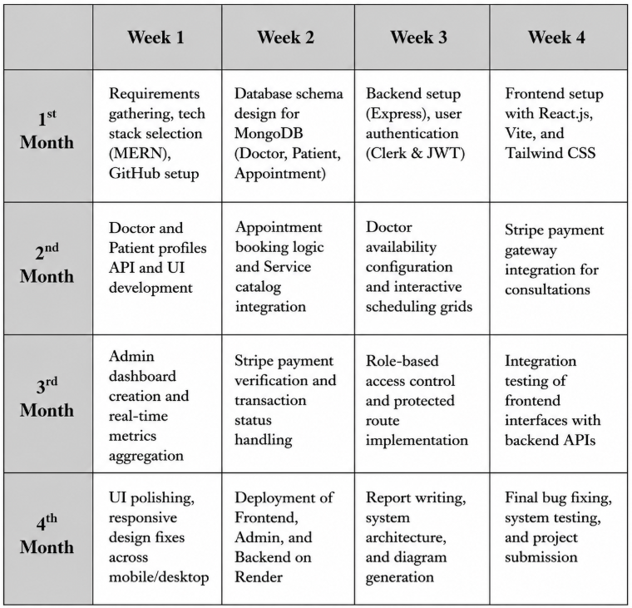
Table 2.4.1 Project Scheduling
2.5 Activity Chart
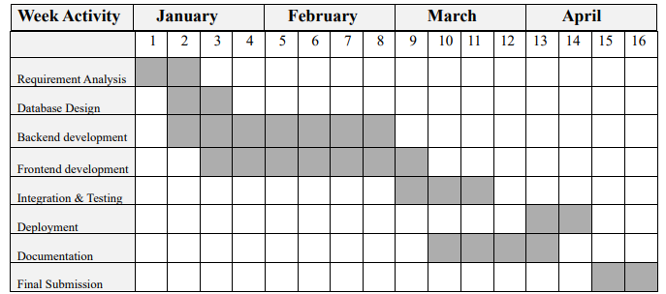
Table 2.5.1 Activity Chart

2.6 Software Engineering Paradigm (Process Model)

Prototype Model
The Medi-Flow project was developed using the Prototype Model as its software engineering paradigm. In this model, instead of completing all requirements before development begins, a working prototype of the system is built early and shared with stakeholders for feedback. Based on that feedback, the prototype is refined step by step until the final system is ready.
This model was chosen for Medi-Flow because the project involved multiple user roles (patient, doctor, admin) with varying requirements that needed to be validated at each stage — such as appointment booking flows, doctor dashboards, and payment integration.

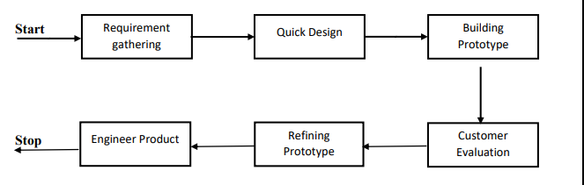
Figure 2.6.1 Prototyping model

The development followed these phases:

Requirement Gathering → Quick Design → Building Prototype → Customer Evaluation → Refining Prototype → Engineer Final Product

Advantages of the Prototype Model:
- Gives users an early working version of the system, building confidence
- Helps clarify unclear requirements and reduces ambiguity
- Improves communication between developers and stakeholders
- Reduces overall project risk by catching issues early Disadvantages of the

Prototype Model:
- Can be time-consuming if multiple rounds of refinement are needed
- Developers may focus too much on speed and compromise code quality
- Users may assume the prototype is the finished product
- Integration of all components may not be considered during early stages

2.7 System Diagrams

2.7.1 Data Flow Diagram (DFD)
A Data Flow Diagram (DFD) serves as a visual illustration of the entire system or specific modules within it. It utilizes standardized, easy-to-understand symbols to map out the flow of data, operational processes, external sources, and data storage points. As a critical modeling tool in software engineering, a DFD effectively outlines the system's architecture, detailing how various components interact and how information circulates throughout the hospital's application.
A DFD essentially demonstrates the trajectory of information as it enters the system, undergoes a series of transformational processes, and exits as an output. Frequently referred to as a bubble chart or a data flow graph, a DFD can be employed at various levels of abstraction to accurately represent the system's structural workflow.
Within the DFD framework, there are four fundamental components:
- Data Flow
- Processes
- External Entities
- Data Stores

1.Data Flow
Data Flow represents the movement of information from one place to another in a system. It acts like a packet of data moving through the system. Data flow can either enter a process as input or leave a process as output. Each flow should contain meaningful information and must be properly labeled, such as “Patient Appointment Request” or “Doctor Schedule.” Input data flows are shown with arrows pointing toward a process, while output data flows are shown with arrows pointing away from the process.

2.Processes
Processes transform input data into useful output data. They represent actions or tasks performed by users, hardware, or software on the data. Since the data changes during processing, the output flow should have a different label from the input flow. Every process must have a clear and action-oriented name, such as “Verify Patient Details” or “Schedule Appointment.”

3.External Entities
External entities are the sources or destinations of data in a system. They may include people like Patients, Doctors, or Administrators, hospital departments, organizations, or third-party software systems. Any outside user or system that sends or receives data from the Hospital Management System is considered an external entity.

4.Data Stores
A Data Store is the storage area or memory of the system where information is saved for future use, such as databases for medical records or user details. A data store must have at least one incoming or outgoing data flow. In diagrams, it is represented by a descriptive label placed between two parallel horizontal lines.

DFD Symbols
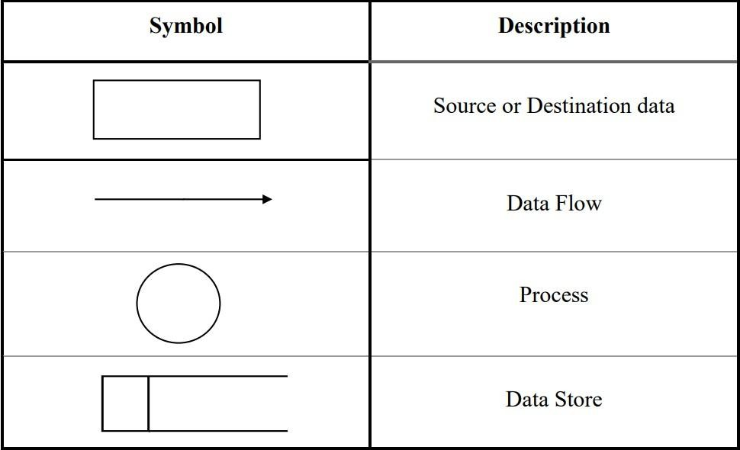
Table 2.7.1 Data flow diagram symbols

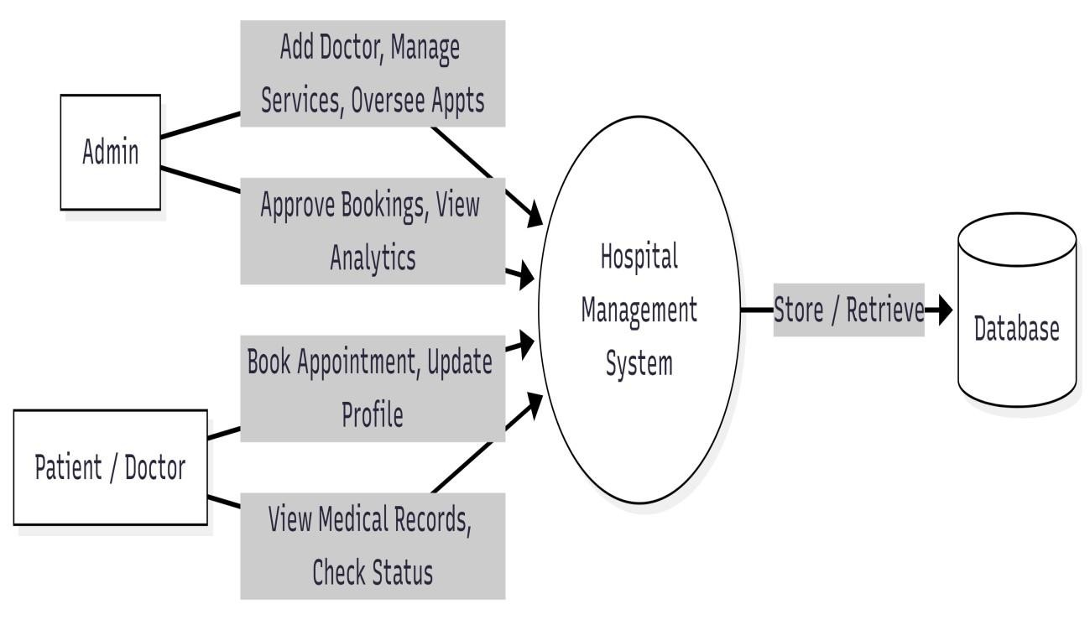

Figure 2.7.1 Level 0 DFD

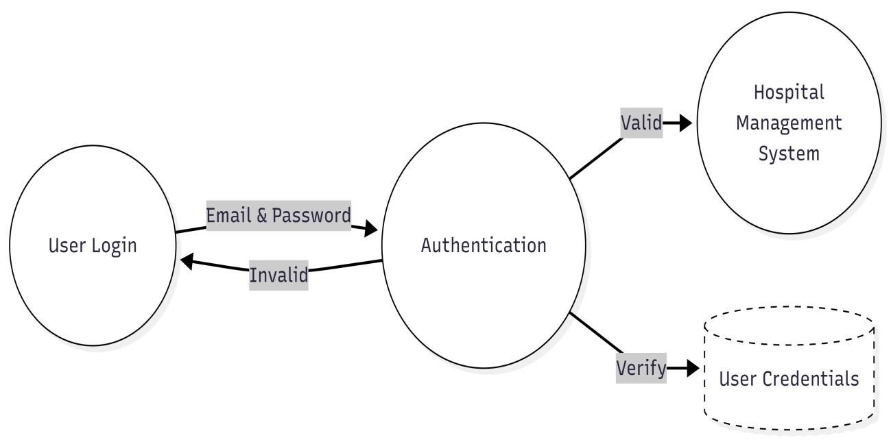
Figure 2.7.2 Level 1 DFD

Level 1 DFD for Admin
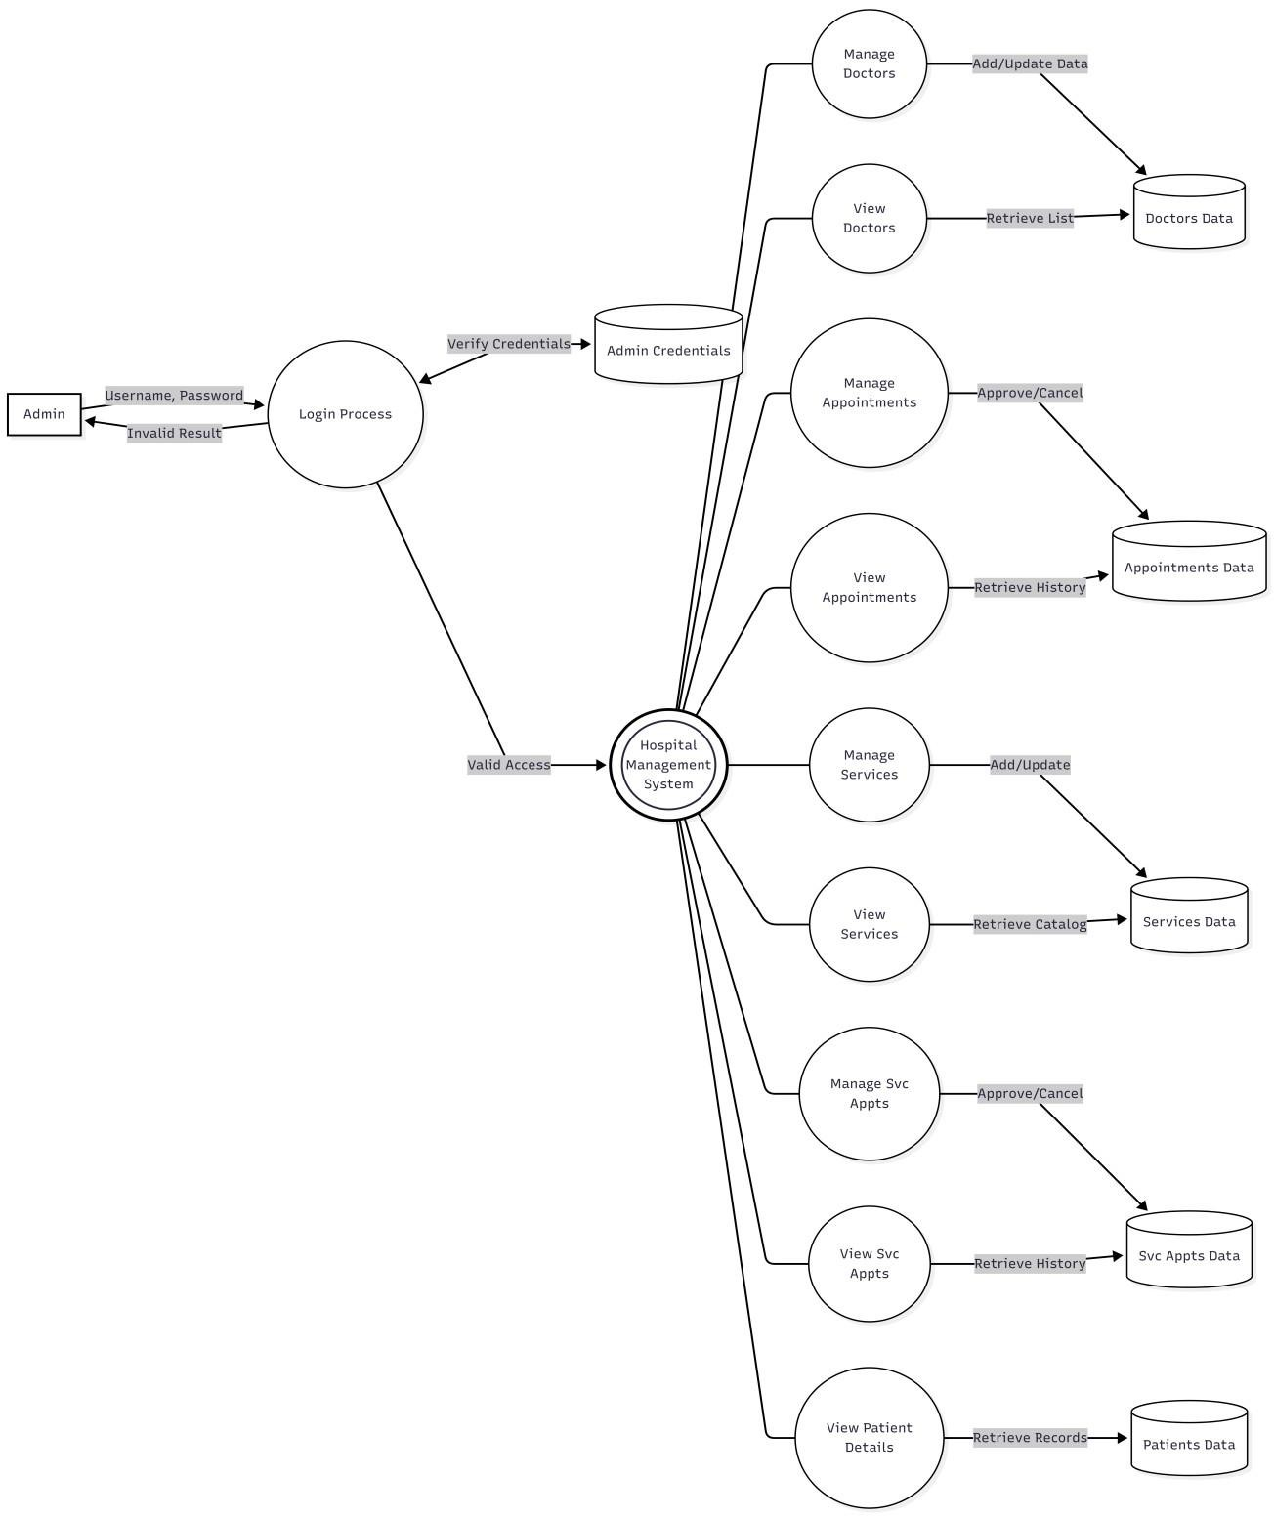
Figure 2.7.3 Level 1.1 DFD

Level 1 DFD for Doctor

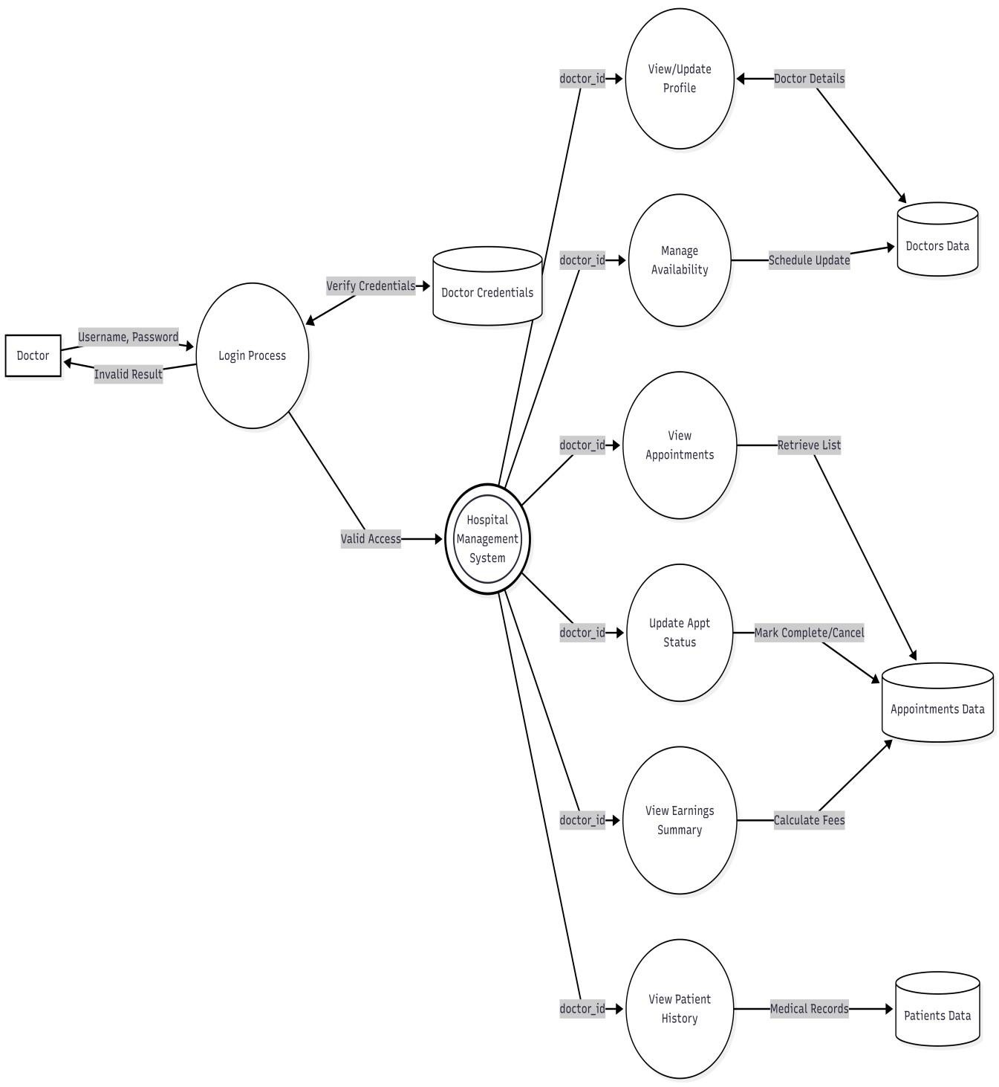
Figure 2.7.4 Level 1.2 DFD

Level 1 DFD for Patient

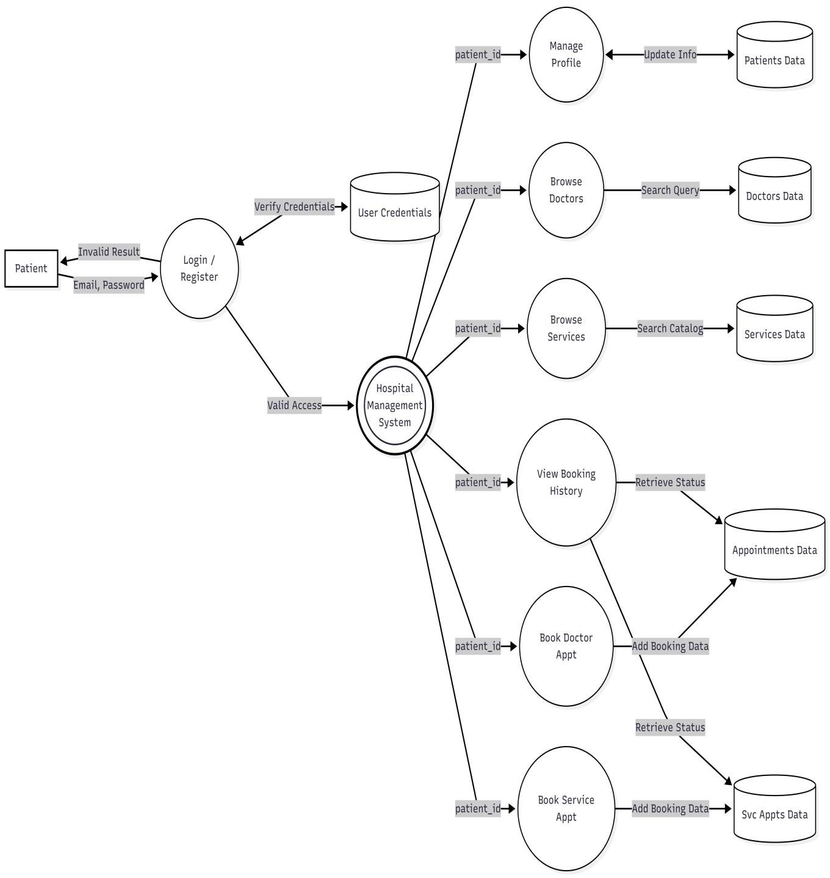

Figure 2.7.5 Level 2 DFD

2.7.2 Entity Relationship Diagram (ER Diagram)
An Entity-Relationship (ER) Diagram is a specialized graphical representation that illustrates the structural interrelationships between various entities within a database. ER diagrams utilize specific, standardized symbols to depict three fundamental types of data architecture: boxes (rectangles) are commonly used to represent entities, diamonds are typically utilized to define relationships between them, and ovals are used to represent the specific attributes of those entities.
In software engineering, an Entity-Relationship Model (ERM) serves as an abstract and conceptual blueprint of the system's knowledge and data structure. Entity-relationship modeling is a highly effective database design method used to produce a conceptual schema or semantic data model of the system—most often for a structured electronic database—by outlining its specific data requirements in a logical, top-down approach.
An entity can be defined as a distinct, real-world object or concept that is capable of independent existence and can be uniquely identified within the system. It serves as a necessary abstraction from the broader complexities of a specific domain. When referring to an entity, we are essentially identifying a specific aspect of the real world that can be clearly distinguished from other surrounding aspects.
An entity can take the form of a physical object or person, such as a hospital room or a registered user; an event, such as a medical consultation or a diagnostic test; or a conceptual idea, such as a medical prescription or a billing invoice. Although the term "entity" is widely used, a technical distinction should ideally be made between an "entity" and an "entity-type." An entity-type represents a broad category, whereas an entity, properly speaking, is a specific single instance of that category. Since an entitytype usually contains many instances and the term itself can be somewhat cumbersome, the term "entity" is universally adopted as a practical synonym. In system modeling, entities can be thought of as nouns. Relevant examples include a patient, a doctor, an appointment, or a medical service. In the ER diagram, these entities are visually represented as rectangles.
A relationship captures exactly how two or more entities are associated or interact with one another within the system. Relationships are typically thought of as actionoriented verbs, serving to logically link two or more nouns together (for example, a Patient books an Appointment, or a Doctor provides a Medical Service).
Examples:
A consults relationship connects a Patient entity to a Doctor entity, a manages relationship connects an Administrator entity to a hospital department, and a books relationship connects a Patient entity to an Appointment entity. Visually, these relationships are represented as diamond shapes, which are connected by straight lines to each of the participating entities.
Entities and relationships can both possess specific attributes. For example, a Patient entity will likely require a unique Patient ID or phone number attribute; similarly, the books relationship connecting a patient to an appointment may possess a date and time attribute indicating exactly when the booking was made. These attributes are visually represented as ellipses (ovals) and are connected to their owning entity or relationship sets by a simple line.
Every entity within the database (unless it is classified as a weak entity) must possess a minimal set of uniquely identifying attributes, which is formally known as the entity’s primary key (e.g., the _id field in a MongoDB database).
Entity-relationship diagrams are designed to map out entity sets and relationship sets broadly; they do not display single, isolated instances of entities or relations. For example, a specific individual doctor is a single entity. The complete collection of all registered doctors within the hospital database constitutes an entity set. Similarly, the specific consults interaction between a particular patient and a doctor is a single relationship instance. The comprehensive collection of all such patient-doctor interactions stored within the database represents a relationship set.
Solid lines are drawn between entity sets and the relationship sets they are involved in to indicate a connection. If every entity in an entity set is absolutely required to participate within a relationship set, a thick or double line is drawn. This mandatory involvement is known as a ‘participation constraint’. If each entity of the entity set is permitted to participate in at most one specific relationship within the relationship set, a directed arrow is drawn from the entity set toward the relationship set. This structural rule is referred to as a ‘key constraint’. To explicitly indicate that every single entity within the entity set is mandatorily involved in exactly one relationship, a thick or double-lined arrow is utilized.

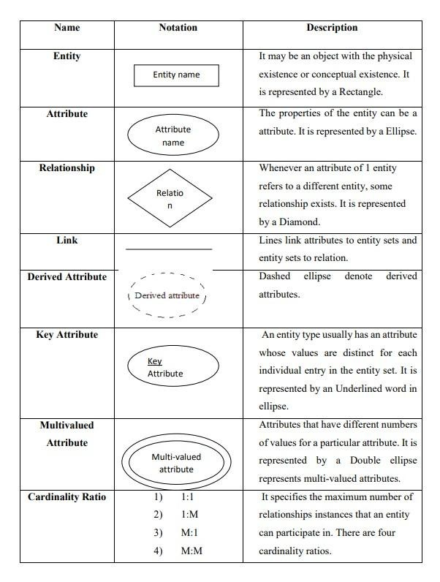

Table 2.7.2 Entity Relationship Diagram

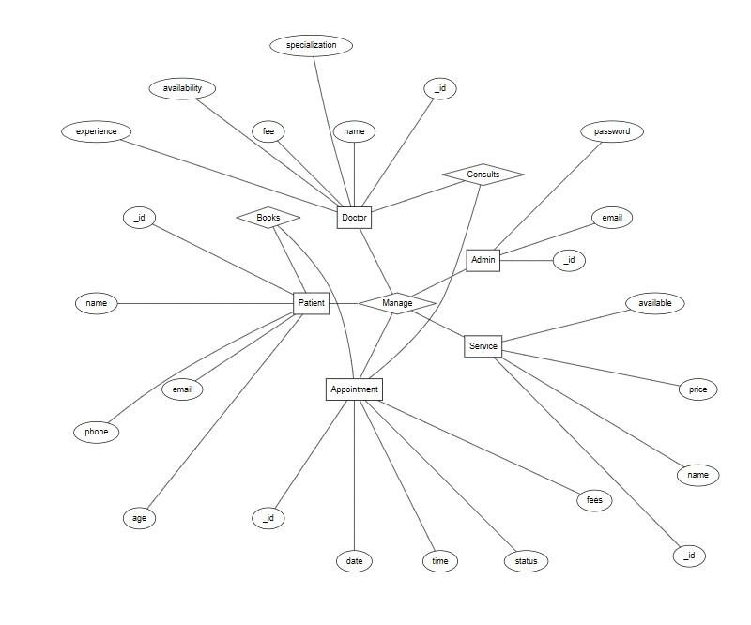
2.7.6 Entity Relationship Diagram

2.7.3 Activity Diagram
Activity diagrams, which are associated with program flow plans (flowcharts), are wont to illustrate activities

Activity diagram for admin
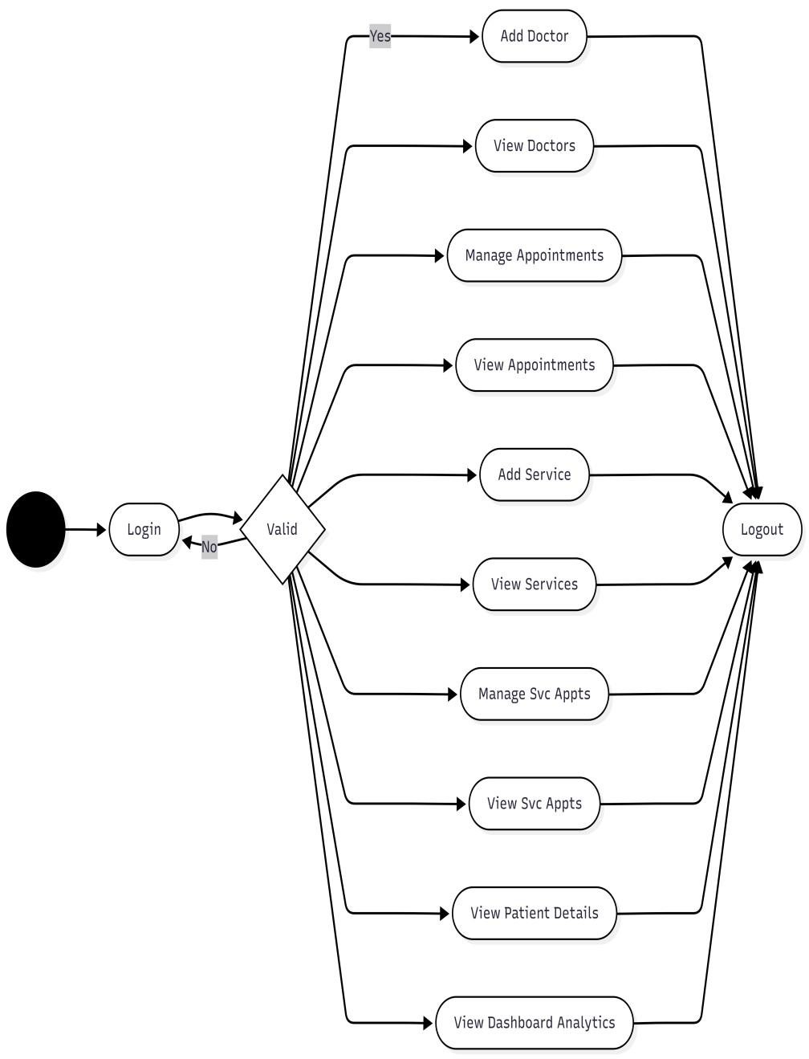
Figure 2.7.7 Activity chart for Admin

Activity diagram for Doctor

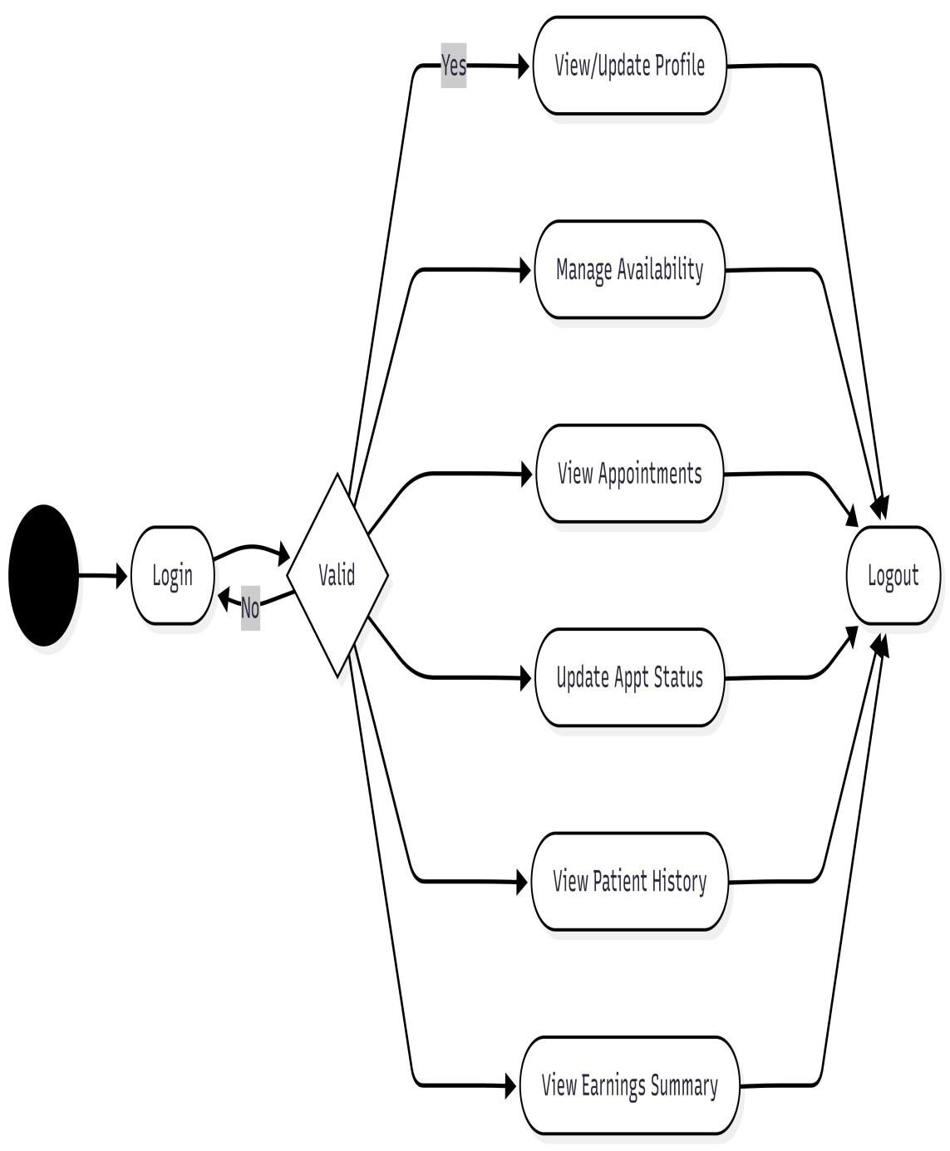
2.7.8 Doctor Activity Diagram

Activity diagram for Patient

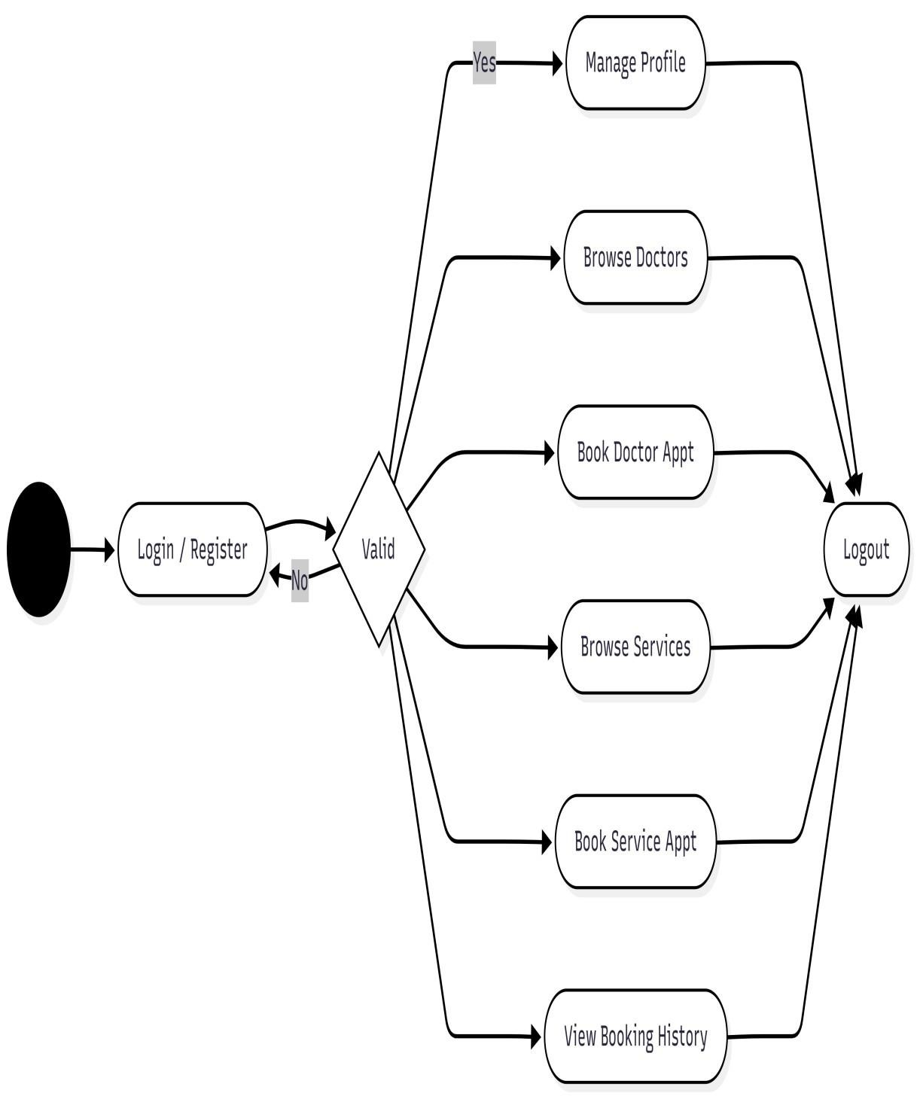
2.7.9 Patient Activity Diagram

2.7.4 Use Case Model
A Use Case Diagram illustrates the core functionality of a system entirely from an enduser’s perspective. Use cases are essential modeling tools utilized during the requirements elicitation and analysis phases to clearly map out what the system is supposed to do. Rather than detailing complex internal technical processes, use case models specialize in defining the external behavior of the system, visually showcasing exactly how different actors (such as Patients, Doctors, and Administrators) interact with the application to achieve their specific goals.

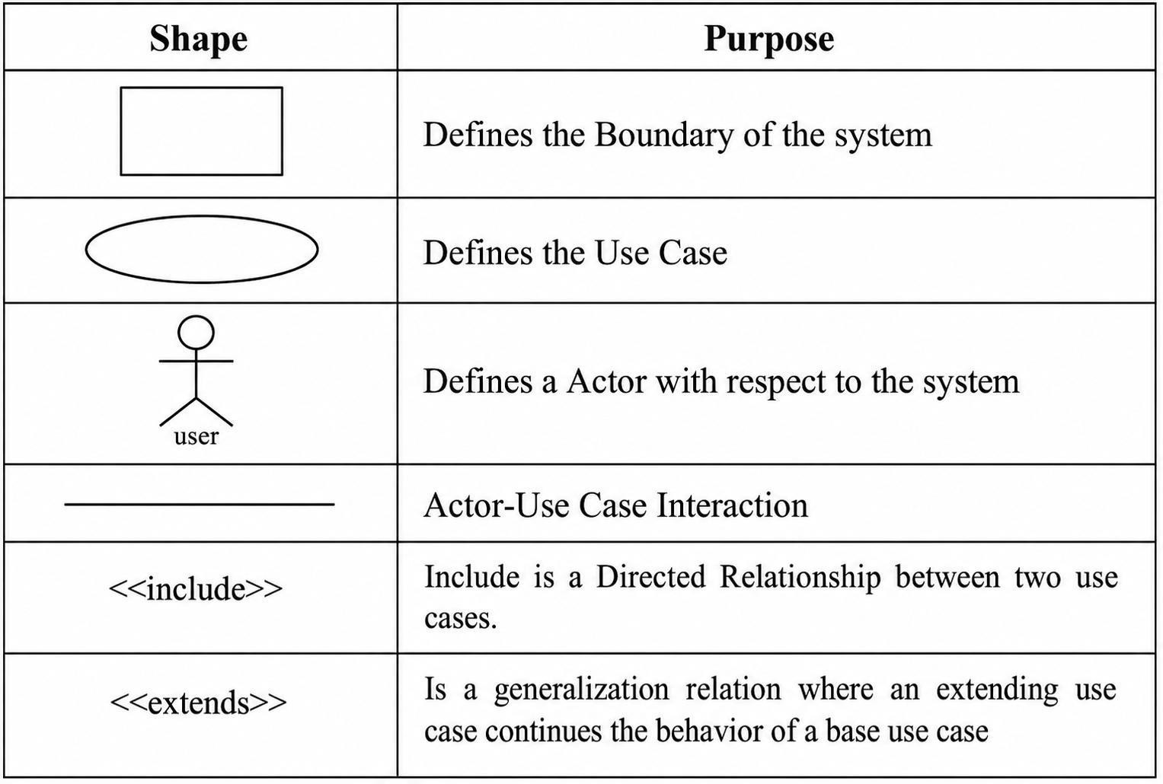
Table 2.7.4 Use Case Model

Use case diagram for admin

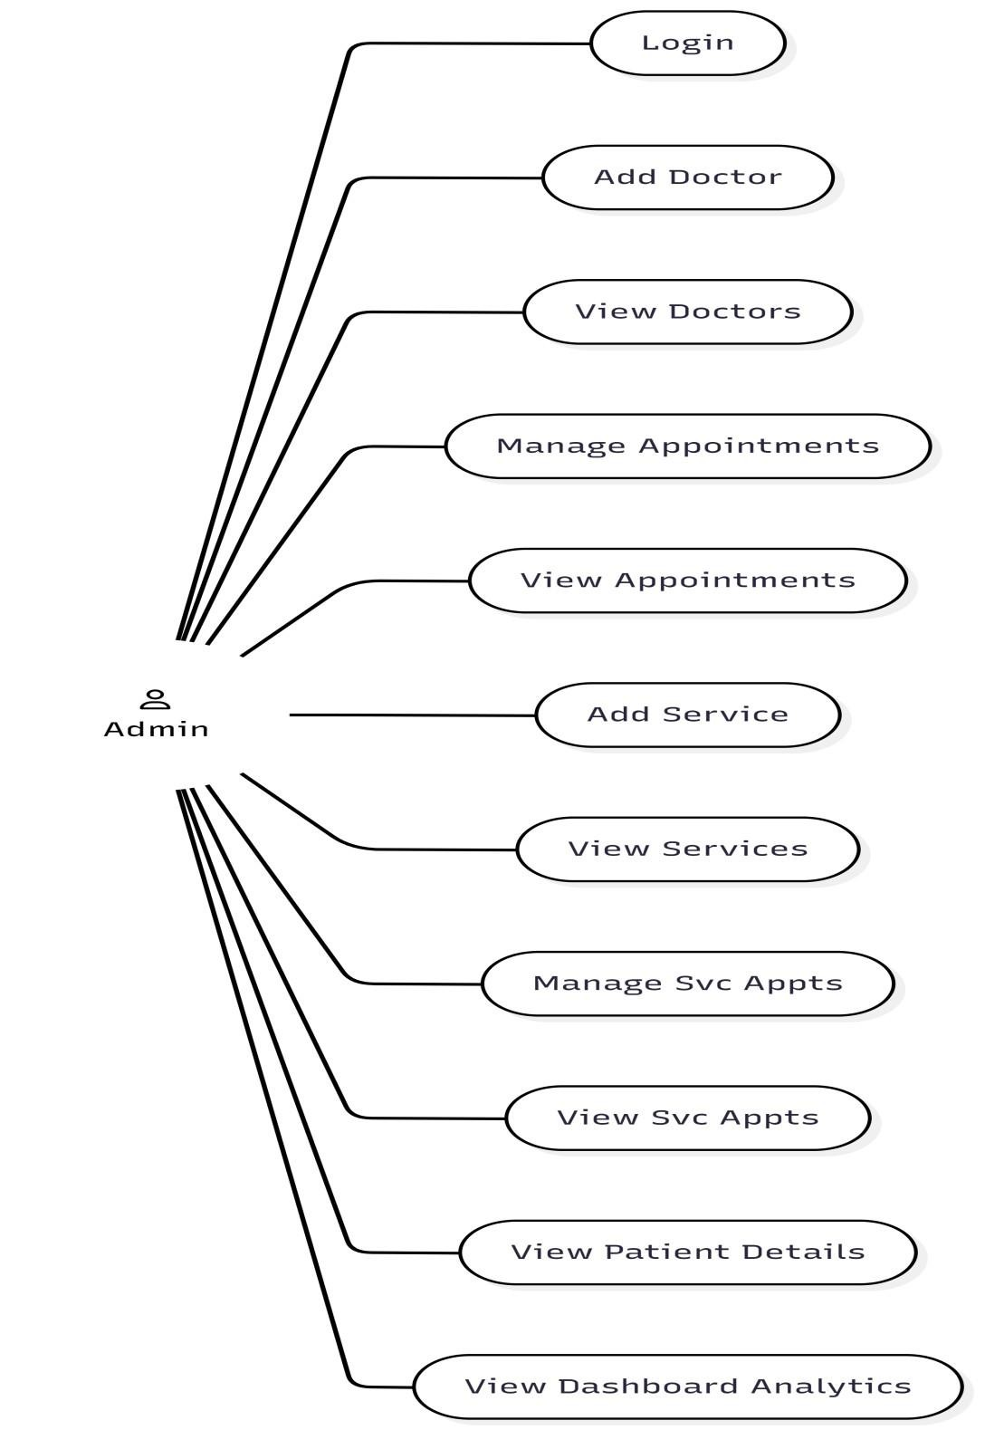

Doctor Use Case Diagram

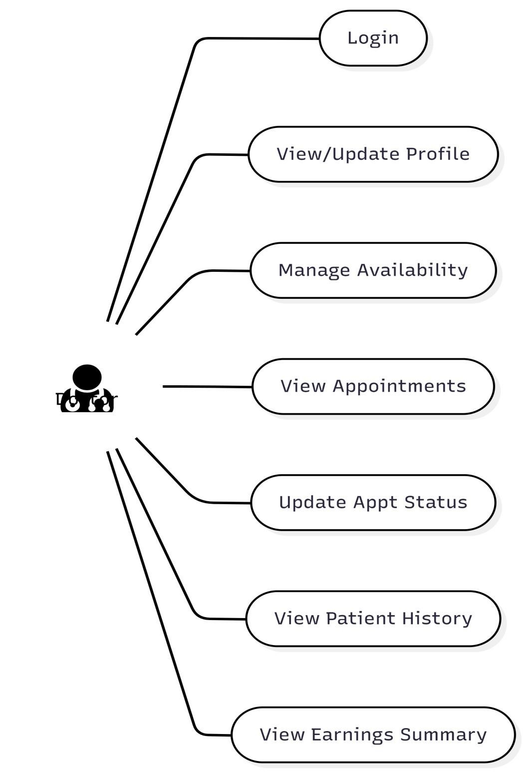

Patient Use Case Diagram

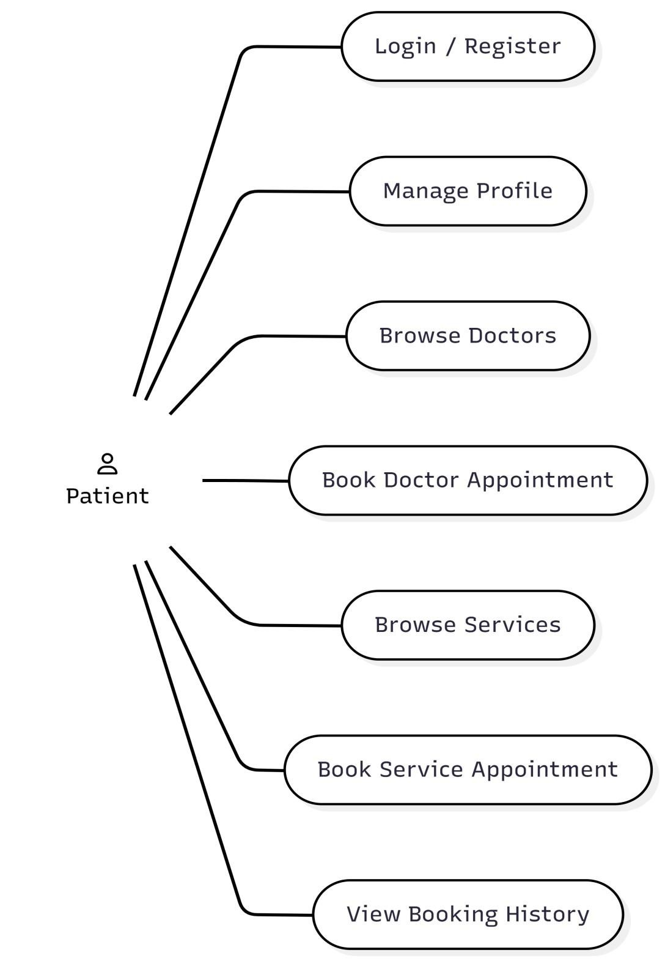

2.8 Software Requirement Specification

2.8.1 Introduction
A Software Requirement Specification (SRS) is a formal, comprehensive document that establishes a shared technical blueprint of the software system's functional and nonfunctional requirements. The primary objective of compiling this SRS is to bridge the conceptual and operational gaps between project stakeholders, clinical administrators, developers, and endusers (patients and practitioners).
In traditional development, communication gaps often arise when clinical administrative staff struggle to comprehend complex software architectures, or when developers lack deep familiarity with healthcare workflows and scheduling constraints. This SRS serves as a unified reference medium that translates medical administration requirements and patient convenience needs into clear, actionable system specifications.
This document contains a complete architectural and behavioral description of the system, detailing the set of interactive scenarios (use cases) that govern user interaction with the application, representing its functional requirements. Furthermore, it outlines crucial non-functional parameters such as system performance, database security, scalability, and integration constraints.
By engaging stakeholders in the drafting of this SRS, the system allows them to critically evaluate clinical workflows, visualize patient-doctor interactions, and establish precise baseline capabilities.
A rigorous, well-structured SRS delivers the following institutional advantages:
- It equips the software development team with a clear, unambiguous roadmap of the functional interfaces and business logic to be constructed.
- It establishes a robust, objective benchmark for quality assurance, user acceptance testing (UAT), and system validation.
- It minimizes design errors, architectural redundancies, and development bottlenecks, leading to a substantial reduction in project lifecycle costs.

2.8.1.1 Purpose
The purpose of this document is to present an exhaustive Software Requirement
Specification for the cloud-based "Medi-Flow" Healthcare Management and Medical Appointment Booking Platform. This SRS provides a clear, detailed framework outlining the technological standards, functional expectations, and operational capabilities of the proposed system.
"Medi-Flow" is a modern, responsive, full-stack web application built using the MERN stack (MongoDB, Express.js, React.js, and Node.js) paired with secure Clerk Authentication and Stripe payment services. The system is engineered to help clinical institutions digitize and automate the scheduling of general doctor consultations and specialized medical/diagnostic services (e.g., MRIs, blood profiles, and therapy sessions). The main objective is to eliminate manual scheduling inefficiencies, prevent doublebookings, facilitate secure online billing, and generate digitized records for both general consultations and laboratory services.
The proposed software addresses the critical friction points of manual scheduling, slow response times, and fragmented offline payment processes. Designed with real-time slot synchronization, it ensures patients can instantly secure appointments, select their preferred payment modes, and complete payments online. This significantly reduces the administrative workload on medical staff and minimizes scheduling errors.

2.8.1.2 Scope
The scope of Medi-Flow encompasses the delivery of an intuitive, patient-centric booking client along with a robust clinical administration dashboard. The system coordinates the tracking of medical practitioner availability, diagnostic lab slot capacities, patient appointment schedules, and transactional histories. By providing automated daily schedule checks, interactive search filters, and immediate booking confirmations, the application streamlines the front-desk operations of modern clinics and healthcare centers.

2.8.1.3 Definitions, Acronyms and Abbreviations
- MERN - MongoDB, Express.js, React.js, Node.js (Full-stack JavaScript architecture)
- REST API - Representational State Transfer Application Programming Interface
- NoSQL - Non-Relational Database (MongoDB)
- ODM - Object Document Mapper (Mongoose)
- CORS - Cross-Origin Resource Sharing
- SPA - Single Page Application
- SRS - Software Requirement Specification
- HTML / CSS - Hypertext Markup Language / Cascading Style Sheets
- RAM / GB - Random Access Memory / Gigabyte

2.8.1.4 References
- React.js Official Framework Documentation: react.dev
- Node.js & Express.js API Design Guide: expressjs.com
- Mongoose ODM Database Modeling Specifications: mongoosejs.com
- Stripe API Payment Gateway Integration Guides: stripe.com/docs
- Clerk Identity Management and Authentication Workflows: clerk.com/docs
- Modern Full-Stack Development Practices with MERN Architecture

2.8.1.5 Overview
This web application is dual-faceted, catering to Patients (End-Users) and Clinical Administrators (Admins). Patients can easily search for doctors by specialty, browse clinic diagnostic packages, view available time slots, book appointments, and complete payments. The Admin Dashboard provides comprehensive control to register medical staff, configure clinical services, oversee patient bookings, resolve scheduling conflicts, and audit payment records, replacing traditional paper registers with a centralized digital ledger.

2.8.2 Overall description

2.8.2.1 Product perspective
Medi-Flow is configured as an independent, self-contained healthcare booking ecosystem. The application does not rely on legacy hospital systems but operates autonomously, hosting a robust React-based client interface, an admin dashboard, a Node/Express middleware server, and a cloud-based MongoDB database cluster. The software interfaces are specified as follows:

2.8.2.1.1 System Interfaces
The client-side single page applications (both frontend and admin interfaces) interact with the backend server through a series of secure, asynchronous RESTful API endpoints. The database layer utilizes Mongoose ODM schemas to index, retrieve, and update records securely, ensuring high data availability across all active network channels.

2.8.2.1.2 User Interfaces
The user interfaces are designed to be responsive, clean, and highly intuitive, accommodating users of varying technical skill levels. Clear visual labels, clean form fields, select dropdowns, responsive grid layouts, and active feedback alerts guide users through booking and administrative tasks.

Patient/User Modules
- User Authentication (Clerk): Allows patients to securely sign up, log in, and manage their personal profiles using secure Clerk OAuth or credential flows.
- Medical Directory: A search-and-filter module where patients can view available doctors categorized by clinical specialties (e.g., Cardiology, Pediatrics, Dermatology).
- Doctor Profile & Details: Displays comprehensive details for chosen doctors, including academic credentials, consultation fees, experience, and an interactive scheduling grid displaying available time slots.
- Clinical Services Catalog: A directory of specialized clinical treatments, diagnostics, or lab procedures (e.g., X-Ray, Blood Test, Physiotherapy).
- Service Profile & Details: Displays service overviews, pricing, duration, and booking triggers.
- My Appointments Page: A central dashboard where patients can monitor active, pending, or completed doctor consultations and clinical service bookings.
- Reschedule / Cancellation Trigger: Allows patients to change their booking times or cancel upcoming appointments, updating the clinical schedule in real-time.
- Stripe Payment & Verification: Integrates secure checkout screens for online payments, routing users back to dynamic payment verification pages to confirm success or failure.

Clinical Admin Modules
- Admin Authentication: A secure administrative entrance with restricted credentials.
- Central Metrics Dashboard: Provides real-time statistics, showing totals for registered doctors, active medical services, pending appointments, and payment transactions.
- Add Doctor: A dedicated portal for administrative staff to input new doctor details, including specialty, qualifications, profile images, and consultation fees.
- Manage Doctors: A comprehensive list where administrators can update existing doctor records, toggle active availability status, or remove records.
- Add Service: A form-based interface to introduce new clinical treatments, packages, or diagnostic tests.
- Manage Services: An administrative list view to update service details, modify prices, or delete inactive procedures.
- Consultation Appointment Dispatcher: Displays all patient appointments for doctor consultations, enabling admins to track scheduling statuses (Pending, Confirmed, Completed, Cancelled) and edit times.
- Service Booking Dispatcher: A specialized board to monitor and verify service bookings (laboratory appointments, diagnostics), update slot details, and verify transaction receipts.

2.8.2.1.3 Hardware Interfaces
• The hardware configuration of the development, testing, and hosting environments required for the Medi-Flow system is defined below:

Hardware Component | Minimum Requirement | Recommended  Specification
Processor | Intel Core i3 (2.0 GHz) or AMD equivalent | Intel Core i5 / AMD Ryzen  5 or higher (including  M1/M2/M3 Apple Silicon)
RAM | 4.0 GB | 8.0 GB or more
Hard Disk | 10 GB HDD | 20 GB SSD of free space  (for node_modules, build directories, and local environment logs)
Input Devices | Standard Keyboard, Mouse, or Touchpad | Keyboard and Precision Pointing Device
Output Devices | Standard Monitor (1024 x 768 resolution) | High-definition display (1920 x 1080 resolution)

2.8.2.1.4 Software Interfaces
The software tools, runtimes, frameworks, and tools used for compiling, running, and deploying Medi-Flow are detailed below:

Software Category | Specification
Operating System | Windows 10/11, macOS (Ventura or newer), or Linux (Ubuntu 20.04 LTS or newer)
Web Browser | Google Chrome, Mozilla Firefox, Apple  Safari, or Microsoft Edge (with ES6+ JavaScript compliance)
Development Tool | Visual Studio Code (VS Code), Git Command  Line Interface, and Node.js environment (v18.0.0 or higher)
Front-end Technology | React.js (Vite environment) and Tailwind  CSS
Database (Back-end) | MongoDB Atlas (Cloud Database) using  Mongoose Object Document Mapper (ODM)
Web Components | HTML5, CSS3, Custom JSX Components, and  ES6+ modules
Scripting Language | JavaScript / Node.js Runtime
Authentication Engine | Clerk Authentication Server & Middleware
Payment Gateway Integration | Specification
Documentation Tool | Windows 10/11, macOS (Ventura or newer), or Linux (Ubuntu 20.04 LTS or newer)

2.8.2.1.5 Communication Interfaces
As a cloud-hosted, database-driven system, Medi-Flow operates entirely over the web. An active internet connection utilizing the secure HTTPS protocol is mandatory for all users (patients, clinical practitioners, and administrators) to fetch availability schedules, authenticate sessions via Clerk, process credit cards via Stripe, and communicate with the MongoDB database cluster.

2.8.2.1.6 Memory Constraints
The server runtime is designed to be highly lightweight and efficient. It can easily operate on standard virtual private servers (VPS) under minimal resource allocations:
- Storage: 5 GB of free SSD storage space is sufficient for hosting backend builds, source assets, and environment runtimes.
- Server RAM: A minimum of 1 GB RAM is required, while 2 GB RAM is highly recommended for smooth Express server operations and Clerk verification handlers.
- Database Storage: MongoDB Atlas cloud storage (shared tier or above) handles storage scalability dynamically.

2.8.2.1.7 Operation
- Administrator: The admin holds administrative permissions to add new medical specialists (doctors) and clinical services (diagnostics/scans) to the portal. The administrator can monitor all general consultation appointments and clinical service bookings, track patient details, review payment logs (Cash or Online), and modify scheduling statuses (Confirm, Cancel, Reschedule) to coordinate frontdesk logistics.
- Patients/Users: Patients are allowed to search and browse doctors and diagnostic services, schedule appointments by selecting active time slots, submit their patient records (name, age, gender, contact number), select a billing method, check out securely via Stripe, and review their history of consultation and lab bookings.

2.8.2.1.8 Site Adaptive Requirements
The Medi-Flow system is built as a responsive web platform. The user interfaces adapt dynamically to varying screen form factors (Mobile, Tablet, Desktop) using Tailwind CSS. The deployment bundle runs across standard web runtimes, requiring no special local machine installations or site-specific modifications.

2.8.2.2 Product Function
The functional capabilities of Medi-Flow represent its core system features. The platform is designed to support the following distinct operations:
Features available to the Administrator:
- Admin is allowed to register new medical specialists (doctors) with complete credentials (specialty, experience, fee, qualification, availability, and profile photo).
- Admin is allowed to add or update clinic services (such as lab tests, scans, or therapy sessions).
- Admin is allowed to view, modify, or remove existing doctors and service items.
- Admin can monitor all active doctor appointments and laboratory service bookings.
- Admin can change appointment statuses (e.g., mark as Confirmed, Completed, Rescheduled, or Canceled).
- Admin is allowed to review payment transaction details, filtering by Cash or Online payments.
Features available to the Patient/User:
- Patients are allowed to securely register and manage their accounts using Clerk Authentication.
- Patients can browse the catalog of general practitioners and search or filter them by medical fields.
- Patients can browse clinical tests and diagnostic services.
- Patients are allowed to view real-time doctor availability slots and book appointments.
- Patients are allowed to fill in booking details (patient name, age, gender, contact number) for each slot.
- Patients can select their payment preference (Cash-on-Arrival or Online Checkout).
- Patients can complete credit card checkouts securely via Stripe integration.
- Patients can view their consolidated booking history, showing real-time updates on scheduling and payment status.
- Patients can cancel or reschedule bookings from their personal dashboard prior to their appointment time.

2.8.2.3 User Characteristics
Medi-Flow is designed as a user-friendly, responsive healthcare application. It can be easily navigated by patients with basic web-browsing skills. The administration portal is built for clinical operators, receptionist staffs, and medical managers, requiring no prior coding experience.
The application incorporates a secure, token-based authorization framework managed by Clerk to prevent unauthorized actions. Only authenticated patients can access personal booking profiles, fill out scheduling forms, or trigger Stripe checkouts.
The administrator holds full administrative privileges, overseeing doctor listings, clinical catalog pricing, calendar synchronization, and appointment statuses. Patients are granted read-and-write permissions only for their own appointment files, personal profiles, and payments.

2.8.2.4 Constraints
- Doctor creation and clinical service configuration are strictly restricted to authenticated administrators.
- To secure a booking, the user must provide a valid mobile number and patient age for validation.
Clerk controls authentication sessions, utilizing verified email addresses, phone numbers, or social sign-ins as the unique identifiers.
- No patient has authorization to view, reschedule, or cancel other patients' appointments.
- Only the admin can manage the master schedule and modify payment status indicators.
- The system is built to handle errors elegantly, displaying user-friendly alerts for network dropouts, booking collisions, or failed transactions.
- The app functions as a self-contained system and does not rely on third-party hospital information systems (HIS).

2.8.2.5 Assumptions and dependencies
- Each client must have a stable internet connection and a modern browser to interact with the backend API.
- The system depends on the online availability of Clerk for user sessions and Stripe for processing credit card checkouts.
- Predefined roles (Patient and Administrator) govern system interactions to maintain high data security.

2.8.3 Specific Requirements

2.8.3.1 External Interface
The user interface is designed to be simple, interactive, and easy to understand. The application prompts patients to sign in using the Clerk user widget before finalizing any clinical bookings. Forms are equipped with real-time validation checks for numerical parameters (such as age), mobile phone format, and date-time scheduling slots. 2.8.3.2 Functions
The functional specification outlines the system inputs, operations, and resulting outputs. It establishes the input-to-output mappings that govern system behavior.

Inputs The input systems are designed to convert patient-entered details into structured JSON payloads. The primary design goal is to make the data entry process error-free, secure, and intuitive. Interactive elements such as date selectors, time picker slots, radio buttons for payment methods, and specialized search bars are utilized to minimize manual typing. Helpful error messages, form placeholders, and interactive dialogues guide the user during input.
Objectives:
- To achieve highly efficient, low-friction booking inputs.
- To achieve the highest possible data validation accuracy, preventing doublebookings.
- To ensure data inputs are highly secure, structured, and sanitized.
Sign up and Login Process:
- The interface features a standardized login gate powered by Clerk.
- Rigorous data validation occurs during patient sign-up (e.g., email verification).
- Authenticated users are granted access tokens to retrieve their secure dashboard, schedule consultations, and manage checkout payments.
The system features two main user roles:

1. Clinical Administrator (Admin) 2. Patient / User

Administrator Functions:
- Create, read, update, and delete (CRUD) listings in the Doctor Directory.
- Create, read, update, and delete (CRUD) listings in the Clinical Services Catalog.
- Access a unified bookings tracker to review all scheduled doctor consultations and diagnostic lab procedures.
- Search, filter, and review appointments based on parameters like patient name, date, payment method, or appointment status.
Review online payment transaction invoices, verifying payment statuses returned by Stripe.
- Confirm, cancel, or update the scheduled dates and times for appointments to manage doctor availability.
Patient/User Functions:
- Search for available doctors and filter them by medical fields (specialties).
- Browse diagnostic test offerings and clinic packages.
- Choose available time slots and schedule appointments for consultations or lab tests.
- Select a payment method: Cash-on-Arrival or secure Online Checkout.
- Pay securely online, routing through Stripe checkout pages, and receive booking validations on the redirect verification screens.
- Monitor personal booking records to track scheduling statuses (Pending, Confirmed, Completed, Cancelled).
- Reschedule or cancel active bookings directly from their dashboard.

2.8.3.3 Performance Requirements
This section outlines the static and dynamic performance parameters governing MediFlow.
- Static Requirements: The system is designed to support hundreds of concurrent active connections. The MongoDB cluster can efficiently index and store thousands of medical practitioners, clinic services, and appointment transactions.
- Dynamic Requirements: System actions are optimized for fast response times. REST API endpoints average a response time of under 200 milliseconds. Time-slot availability syncs immediately across open browsers to avoid scheduling conflicts. Performance is dependent on the user's internet connection and API availability.

2.8.3.4 Logical Database Requirements
All transactional data is stored securely in a MongoDB NoSQL database. Mongoose ODM handles structural schemas for data consistency:
Doctor Collection: Stores names, medical specialties, fees, availability slots, experiences, qualifications, and profile image coordinates.
- Service Collection: Records diagnostics/scans, description copy, pricing, and category identifiers.
- Appointment Collection: Details patient information, doctor identifiers, scheduled times, billing modes, and payment states (Paid, Pending, Refunded).
- ServiceAppointment Collection: Links patient records to diagnostic test bookings with slot allocations and Stripe session logs.
The database supports secure concurrent operations and maintains data integrity using Mongoose indexing.

2.8.3.5 Design Constraints
The architectural design and implementation constraints governing the MediFlow application are detailed as follows:
- Technology Stack Alignment: The application is built entirely upon a
JavaScriptcentric runtime, utilizing React.js for the client-side SPA, Express.js and Node.js for the server-side API engine, and MongoDB for database services.
- Interoperability: The user interface supports seamless input synchronization across touchscreens, keyboards, mouse click systems, and assistive input peripherals.
- Error and Feedback Handling: All operational errors, data exceptions, network dropouts, and validation checks must be rendered dynamically via elegant pop-up toasts, modal dialogues, or contextual visual labels rather than browser alerts.
- Data Validation: Strict validation engines are implemented at both the client layer (via React form hooks) and the database schema layer (via Mongoose model validations) to ensure data integrity.
- Component Selectability: Dynamic selection fields, interactive date pickers, time slot selector modules, and structured specialty filter categories are utilized to make input collection reliable and easy.
Connectivity Requirements: Because the platform interfaces with external cloud gateways (MongoDB Atlas, Clerk Auth, Stripe Checkout), a continuous HTTPS internet connection is required for all features.
2.8.3.6 Software System Attributes

Reliability
Medi-Flow is engineered to maintain high computational reliability. The backend utilizes secure connection managers to ensure database operations continue smoothly without slot conflicts or double-booking errors. Data security is protected via automatic MongoDB Atlas cloud mirroring and daily scheduled backups, minimizing the risk of data loss.

Availability
The system is built to ensure high operational availability (>99.9% uptime). The frontend bundle is hosted on a high-availability content delivery network (CDN), and the Express APIs are deployed on scalable hosting instances to ensure round-the-clock patient and admin access.

Security
Security is handled using a multi-layer framework. User session management and identity verification are securely outsourced to Clerk, which employs secure JSON Web Tokens (JWT) and encryption. Passwords and credentials are encrypted on the auth servers, ensuring that unauthorized clients are blocked from accessing admin panels or booking data. Furthermore, all credit card transactions are handled natively by Stripe, adhering to strict PCI-DSS security guidelines.

Flexibility
The application code is structured in a highly modular, decoupled fashion. Decoupled Express routers, reusable React components, and dynamic Mongoose schemas allow developers to quickly add new medical disciplines, clinic services, or scheduling systems without modifying the core codebase.

Timeliness
High execution speed is maintained by using lightweight JSON APIs, asynchronous JavaScript operations, and optimal MongoDB indexes. System search operations, specialty filtering, and slot selections are executed with minimal server latency.

Maintainability
The separation of concerns between the React frontend client, Node/Express API server, and MongoDB Atlas database ensures high maintainability. The database layer requires no manual server maintenance from clinic staff, as hosting configurations, schema updates, and scale adjustments are managed through cloud dashboards.

Correctness
The application guarantees structural correctness by matching booking outputs, time slot availability, and patient profiles perfectly against user selections and business scheduling policies.
2.8.4 Change Management Process
To integrate ad hoc changes in clinical rules or user requirements, an iterative, agile change management process is used. This process consists of the following structured workflow:
A detailed change implementation plan is compiled to evaluate the impact of proposed updates on both the frontend UI and database models. The software team then works on adding the new requirements within isolated Git feature branches.
Once written, the updated codebase is run through rigorous regression testing to verify that existing features (such as Stripe checkouts or Clerk auth sessions) are unaffected. During the validation phase, test cases are executed to ensure the new requirements are met.
After completing development and testing, all technical project documents and API specifications are updated to reflect the new state. A final verification check is executed, and a new stable production build is deployed to the hosting environment.

2.8.5 Document Approvals
- Approved By:
- Signature: ______________________
- Date: ______________________

2.8.6 Supporting Information

Node.js
Node.js is an open-source, cross-platform JavaScript runtime environment designed for building scalable network applications. Created by Ryan Dahl in 2009, Node.js allows developers to execute JavaScript on the server side, breaking the historical constraint of JavaScript being limited to client-side web browsers.
Node.js is built on Google Chrome’s V8 JavaScript engine, compiling JavaScript code directly into native machine code for fast execution. A key architectural design point of Node.js is its event-driven, non-blocking I/O model. Instead of creating a new thread for every incoming client connection (which consumes high memory), Node.js uses a singlethread event loop to handle concurrent connections asynchronously.
This non-blocking architecture makes Node.js highly efficient and perfect for dataintensive, real-time web applications like Medi-Flow, which manage many concurrent booking requests and API calls. Backed by npm (Node Package Manager), the largest ecosystem of open-source libraries in the world, Node.js facilitates rapid backend development.

Express.js
Express.js (or simply Express) is a minimal, flexible, and open-source web application framework for Node.js, designed for building robust web applications and RESTful APIs. Created by TJ Holowaychuk in 2010, Express serves as the de facto standard server framework for Node.js developers and is a core component of the MERN stack.
Express provides a thin layer of fundamental web application features, such as routing, middleware integration, template rendering, and HTTP request/response handling, without obscuring the core features of Node.js.
In Medi-Flow, Express plays a vital role by organizing server routing for various APIs (including doctors, services, appointments, and payments) and executing crucial middleware functions, such as Clerk JWT verification, input validation, and CORS handling. Express simplifies the task of mapping HTTP requests to server-side controllers and database queries.

MongoDB and Mongoose ODM
MongoDB is a leading open-source, document-oriented NoSQL database system designed for high scalability, performance, and developer agility. Unlike traditional relational databases that store data in rigid tables, rows, and columns, MongoDB stores data in flexible, JSON-like BSON (Binary JSON) documents.
This document model maps directly to objects in application code, making data manipulation intuitive. MongoDB supports a dynamic schema design, meaning documents in the same collection can have varying fields and structures, which is ideal for modeling diverse clinical appointments or doctor profiles.
Mongoose is an Object Document Mapper (ODM) library specifically built for MongoDB and Node.js. It acts as a bridge between MongoDB's raw document structures and Express.js logic by providing a schema-based solution to model application data.
Mongoose allows developers to define structured schemas, enforce strict data validation rules, perform complex database queries, and manage document relationships (referencing other models using ObjectIds). In Medi-Flow, Mongoose defines the schemas for Doctor, Service, Appointment, and ServiceAppointment, ensuring clean validation and seamless database queries.
Key Design Features of MongoDB & Mongoose:
- Flexible Document Schema: Documents map natively to JavaScript objects.
- Mongoose Schema Validation: Prevents malformed data from being written to the database.
- ObjectId Referencing: Facilitates relational structures within a NoSQL database.
- Indexing Capability: Optimizes query speeds for time-slot lookups and search filtering.
- MongoDB Atlas Integration: Highly secure, cloud-hosted database setup with built-in backup and scaling capabilities.

React.js
React.js is an open-source, declarative, and component-based JavaScript library designed by Meta (formerly Facebook) in 2013 for building highly interactive and responsive user interfaces, primarily for single-page applications (SPAs).
Instead of manipulating the browser’s Document Object Model (DOM) directly—which is slow and resource-intensive—React uses a Virtual DOM. When changes are made, React computes a diff between the Virtual DOM and the real DOM, rendering only the components that have changed, which significantly boosts application performance.
React's component-based architecture allows developers to build modular, selfcontained UI components (such as doctor cards, reservation calendars, and navigation menus) that manage their own state and can be combined to form complex web views.
In Medi-Flow, React.js handles the client-side rendering, routing, state management, and real-time interface rendering for both the patient-facing booking application and the administrative panel.

Tailwind CSS
Tailwind CSS is a utility-first CSS framework designed to build custom user interfaces quickly. Instead of writing custom CSS rules in separate style sheets or using predesigned UI components, developers apply utility classes directly in their HTML/JSX components (e.g., flex, pt-4, text-center, rounded-lg).
Tailwind processes these utility classes to compile a highly optimized, purged CSS bundle. This utility-first methodology ensures consistent designs, speeds up development, and eliminates bloated CSS code, giving developers complete control over the responsive presentation layout of the Medi-Flow system.

Clerk Authentication
Clerk is a comprehensive identity management and user authentication service built for modern web frameworks. It handles secure login, signup, user profile management, session tracking, and multi-factor authentication (MFA) via a set of pre-built UI components and API tools.
In Medi-Flow, Clerk secures patient profiles and admin panels, utilizing JWT validation middleware to restrict backend API routes from unauthorized clients.

Stripe Payments
Stripe is a suite of developer APIs that powers secure online payment processing. It allows applications to accept credit cards, digital wallets, and local payment methods securely without handling raw card details directly on the server, ensuring PCI-DSS compliance.
In Medi-Flow, Stripe facilitates online booking checkouts, using secure webhook endpoints to update appointment payment statuses in real-time.

3. System Design

3.1 Data Design

3.1.1 Database Design
An organized database design is crucial for managing the large datasets generated by Medi-Flow, such as practitioner lists, diagnostic directories, booking logs, and transactional records.
Database design involves defining the structural models of storage collections, establishing relationships between entities, and implementing indexing mechanisms to query data efficiently and securely, even in the event of system failures.
To build an efficient, secure database for Medi-Flow, the following design objectives are implemented:
- Controlled Redundancy: Striking a balance between referencing documents and embedding data to minimize redundancy without sacrificing database query speeds.
- Ease of Access: Creating query-friendly document models that allow fast search, filtering, and CRUD operations.
- Data Independence: Isolating the database schemas from the client UI code, relying on Express controllers as mediators.
- Accuracy and Integrity: Using Mongoose schema rules to validate types, ranges, enums, and required parameters before writing data.
- Performance Optimization: Creating custom indexes on frequently searched parameters (such as booking dates, doctor IDs, and Stripe session identifiers).
- Security & Recoverability: Hosting the database on MongoDB Atlas, ensuring automated cloud backups, secure connections, and restricted access IP whitelists.
The data design process consists of 5 conceptual stages:
- Identify Collections and Relationships: Determine the core collections (Doctors, Services, Appointments) and map out how they link together.
- Define Document Structure: Establish the specific key-value fields, data types, and default settings for each collection.
- Resolve Relationships: Decide where to use document nesting (embedding) versus document linking (referencing ObjectIds).
- Schema Verification: Validate the models against the system's business rules and scheduling constraints.
- Database Implementation: Initialize Mongoose models in Node.js and establish the connection to MongoDB Atlas.

Applicable Documents
The Database Design relies on the System Design document, which defines the general application flow. The second applicable source is the Software Requirement Specification (SRS), which details the modular behaviors, user actions, and field requirements.

Document Structure and Relationships (MERN Paradigm)
While relational databases rely on normal forms (1NF, 2NF, 3NF) to eliminate data redundancy across tables, document-based NoSQL systems like MongoDB use alternative structures to maintain data integrity and optimize performance:
- Structured Document Schema: Translates the principles of 1NF by ensuring that all collection documents are structured consistently. Each document has a unique, automatically generated primary key (_id), and nested attributes are structured inside clear sub-documents rather than unstructured arrays.
- Entity Referencing: Translates 2NF principles by using unique ObjectIds to create relationships between collections. For example, rather than repeating full doctor details inside every appointment record, the Appointment document stores a doctorId reference key linking it back to the Doctor collection.
- Dynamic Nesting vs. Referencing: Translates 3NF principles by deciding between embedding and referencing. Unchanging, context-specific data (such as the doctor's name, fee, and specialty at the time of booking) is stored directly inside the appointment document to prevent changes in doctor profiles from retroactively altering historical booking records. Meanwhile, active calendars and specialties remain normalized inside the master collections for easy updates.
The detailed structures of the schemas and collections utilized within the various MediFlow operational modules are defined as follows:

1. Collection Name: Doctor
This collection registers medical practitioners, their specialties, credentials, consultation fees, active clinic location coordinates, rating indexes, and calendar scheduling mappings.

Sl. No | Field Name | Data  Type | Description | Constraint

1 | _id | ObjectId | Document primary  identifier | Primary Key (Auto-Generated)
2 | email | String | Practitioner email address | Required, Unique, Lowercase, Indexed
3 | password | String | Hashed verification password | Required, Hidden on Selection (select: false)
4 | name | String | Doctor's full name | Required, Trimmed
5 | specialization | String | Area of expertise (e.g. Cardiology) | Optional (Default: “ “)
6 | imageUrl | String | Cloud storage URL for profile image | Optional (Default: null)
7 | imagePublicId | String | Cloud storage reference ID | Optional (Default:null)
8 | experience | String | Years of medical practice | Optional (Default:” “)
9 | qualification | String | Academic medical degrees | Optional (Default:” “)
10 | location | String | Clinical consultation room/location | Optional (Default: ” “)
11 | about | String | Professional summary/biography | Optional (Default: ” “)
12 | fee | Number | Consultation pricing per slot | Optional (Min: 0, Default: 0)
13 | availability | String | Active booking status | Enum: ["Available",  "Unavailable"] (Default: "Available")
14 | schedule | Map  (Array of  Strings) | Available time slot schedules | Optional (Default:{})
15 | success | String | Highlight statistic or success rate | Optional (Default:” “)
16 | patients | String | Numeric summary of patients treated | Optional (Default:” “)
17 | rating | Number | Overall review star index | Optional (Default: 0)
18 | createdAt | Date | Timestamp of profile registration | Auto-Generated (Mongoose Timestamps)
19 | updatedAt | Date | Timestamp of profile modifications | Auto-Generated (Mongoose Timestamps)

2. Collection Name: Service
This collection catalogs specialized laboratory tests, diagnostic procedures (e.g., MRIs, blood profiles), duration costs, patient instructions, and availability toggles.
Sl. No | Field Name | Data Type | Description | Constraint
1 | _id | ObjectId | Document primary  identifier | Primary Key (AutoGenerated)
2 | name | String | Clinical service name (e.g.,  MRI Scan) | Required,  Trimmed,  Indexed
3 | about | String | Detailed clinical description | Optional  (Default:” “)
4 | shortDescription | String | Concise visual description snippet | Optional  (Default: “ “,  Indexed)
5 | price | Number | Total fee of diagnostic procedure | Optional (Min: 0, Default: 0)
6 | available | Boolean | Active clinical booking status | Optional (Default: true)
7 | imageUrl | String | Cloud storage  URL for service illustration | Optional  (Default: null)
8 | imagePublicId | String | Cloud storage reference ID | Optional  (Default: null)
9 | dates | Array (Strings) | Available scheduling calendar days | Optional  (Default:[])
10 | slots | Map (Array of Strings) | Hourly time slot listings | Optional  (Default:{})
11 | instructions | Array (Strings) | Special pretest  patient  instructions | Optional  (Default:[])
12 | totalAppointments | Number | Consolidated count of bookings | Optional  (Default: 0)
13 | completed | Number | Successful booking completions | Optional  (Default: 0)
14 | canceled | Number | Total booking cancellations | Optional  (Default: 0)
15 | createdAt | Date | Timestamp of service creation | AutoGenerated  (Mongoose  Timestamps)
16 | updatedAt | Date | Timestamp of service modifications | AutoGenerated  (Mongoose  Timestamps)

3. Collection Name: Appointment
This collection logs user reservations for medical consultations, tracking patient demographics, selected dates, booking state indicators, and Stripe transaction logs.
Sl.  No | Field Name | Data Type | Description | Constraint
1 | _id | ObjectId | Document primary  identifier | Primary Key (Auto-Generated)
2 | owner | String | Unique Clerk user ID of account holder | Required, Indexed
3 | createdBy | String | ID of scheduling initiator (User/Admin) | Optional (Default: null, Indexed)
4 | patientName | String | Name of the patient receiving care | Required, Trimmed
5 | mobile | String | Mobile number for booking alerts | Required, Trimmed

6 | age | Number | Age of the patient | Optional (Min: 0, Default: null)
7 | gender | String | Gender of the patient | Optional (Default:” “)
8 | doctorId | ObjectId | Reference link to Doctor collection | Required, Ref: "Doctor", Indexed
9 | doctorName | String | Cached doctor name for historical records | Optional (Default: “ “)
10 | speciality | String | Medical field specialization of doctor | Optional (Default: “ ”)
11 | doctorImage | Object | Nested fields url and publicid | Optional (Default empty strings)
12 | date | String | Scheduled consultation date | Required
13 | time | String | Scheduled consultation time | Required
14 | fees | Number | Cached consultation fee applied | Required (Min: 0, Default: 0)
15 | status | String | Current execution state of booking | Enum: ["Pending", "Confirmed",  "Completed", "Canceled", "Rescheduled"]
16 | rescheduledTo | Object | Nested reschedule date and time slots | Optional
17 | payment.method | String | Method of billing | Enum: ["Cash", "Online"] (Default: "Cash")
18 | payment.status | String | Current status of checkout transaction | Enum: ["Pending", "Paid", "Failed", "Refunded"] (Default: "Pending")
19 | payment.amount | Number | Total transaction amount charged | Optional (Default: 0)
20 | payment.providerId | String | Transaction reference ID (e.g. Stripe checkout) | Optional (Default: “ “)
21 | payment.meta | Mixed | Metadata object of the transaction | Optional (Default: {})
22 | sessionId | String | Stripe Checkout Session  ID | Optional (Default: null, Indexed)
23 | paidAt | Date | Timestamp of checkout payment | Optional (Default: null)
24 | createdAt | Date | Timestamp of booking creation | Auto-Generated (Mongoose Timestamps)
25 | updatedAt | Date | Timestamp of booking updates | Auto-Generated (Mongoose Timestamps)

4. Collection Name: ServiceAppointment
This collection logs user reservations for diagnostic tests and clinical laboratory procedures, tracking patient details, scheduling configurations, and payment states.
Sl.  No | Field Name | Data Type | Description | Constraint
1 | _id | ObjectId | Document primary  identifier | Primary Key (Auto-Generated)
2 | createdBy | String | Unique Clerk user ID of account holder | Optional (Default: null, Indexed)
3 | patientName | String | Name of patient receiving diagnostic care | Required, Trimmed

4 | mobile | String | Mobile number for booking alerts | Required, Trimmed
5 | age | Number | Age of the patient | Optional (Min: 0)
6 | gender | String | Gender of the patient | Enum: ["Male", "Female", "Other",  ""] (Default: "")
7 | serviceId | ObjectId | Reference link to Service collection | Required, Ref: "Service", Indexed
8 | serviceName | String | Cached service name for historical records | Required
9 | serviceImage | Object | Nested fields url and publicId | Optional (Default empty strings)
10 | fees | Number | Cached clinical pricing applied | Required (Min: 0)
11 | date | String | Scheduled diagnostic date | Required, Indexed (Compound Index)
12 | hour | Number | Hour coordinate of booking (1-12) | Required
13 | minute | Number | Minute coordinate of booking (0-59) | Required
14 | ampm | String | Clock meridian coordinate of booking | Required, Enum: ["AM", "PM"]
15 | status | String | Current execution state of service booking | Enum: ["Pending", "Confirmed",  "Rescheduled", "Completed", "Canceled"], Indexed
16 | rescheduledTo | Object | Nested date, hour, minute, and ampm fields | Optional
17 | payment.method | String | Method of billing | Enum: ["Cash", "Online"] (Default: "Cash")
18 | payment.status | String | Current status of checkout transaction | Enum: ["Pending", "Paid", "Failed", "Refunded"] (Default: "Pending")
19 | payment.amount | Number | Total transaction amount charged | Required
20 | payment.providerId | String | Transaction reference ID | Optional (Default:” “)
21 | payment.paidAt | Date | Timestamp of checkout payment | Optional (Default: null )
22 | payment.sessionId | String | Stripe Checkout Session ID | Optional (Default:” “, Indexed)
23 | payment.meta | Mixed | Metadata object of the transaction | Optional (Default: {})
24 | createdAt | Date | Timestamp of booking creation | Auto-Generated (Mongoose Timestamps)
25 | updatedAt | Date | Timestamp of booking updates | Auto-Generated (Mongoose Timestamps)

3.2 System Architectural Design
The Medi-Flow system is designed around a modern, decoupled Client-Server Architecture utilizing the MERN Stack (MongoDB, Express.js, React.js, and Node.js). This design incorporates a Model-View-Controller-Router (MVCR) paradigm with dedicated service layers, separating concerns to allow independent development of client layouts, backend business logic, and cloud database storage.

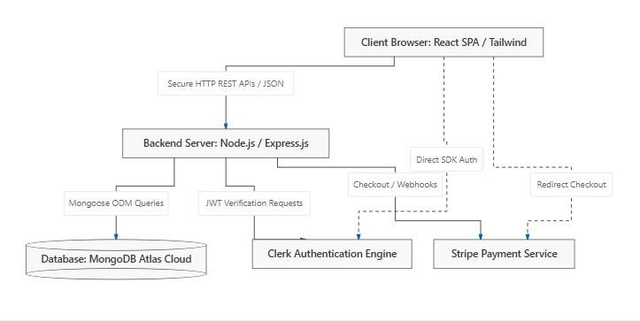

Model:
The model layer represents the dynamic database structure of the application and is decoupled from the user interface. In Medi-Flow, this layer is implemented using
MongoDB collections defined by Mongoose ODM schemas. The models (such as Doctor, Service, Appointment, and ServiceAppointment) directly manage the validation, indexing, rules, and storage of persistent clinical data.
View:

The view layer represents the presentation of data to the end-users (patients and clinical administrators). In Medi-Flow, the view is built as a highly responsive Single Page Application (SPA) using React.js and Tailwind CSS. The views dynamically fetch and render JSON data from the REST APIs, presenting clean schedules, doctor specialties, diagnostic categories, and appointment timelines. Multiple views of the same underlying data are generated (e.g., a patient-centric reservation list and an admincentric schedule dashboard).

Controller:
The controller layer processes incoming user inputs and updates the models or views accordingly. In Medi-Flow, this layer consists of asynchronous JavaScript controller functions running inside the Node/Express.js backend.
- The models manage the database state and enforce Mongoose schema-level constraints under instructions from the backend controllers.
- The views present real-time application data, dynamically updating as state changes are pushed from the backend.
- The controllers receive API requests from the React client, validate and sanitize parameters, verify user identity using authentication tokens, execute database operations, and return appropriate JSON responses or HTTP status codes.
By separating the application into distinct frontend client and backend server components, Medi-Flow ensures a modular structure that can be easily customized or scaled to support additional integrations.
Integrated Services:
Between the backend controllers and the database models, Medi-Flow implements specialized service layers to handle complex, asynchronous external operations. Instead of writing heavy custom service functions, Medi-Flow uses dedicated cloud service integrations:
Authentication Service (Clerk): Handles user verification, secure logins, and session management, separating authentication details from the core database.
Payment Processing Service (Stripe): Coordinates secure checkout sessions and utilizes webhook services to notify the controllers when payments are completed successfully.
This service-oriented design isolates external payment and identity workflows, keeping the core controllers lightweight, readable, and highly maintainable.

3.3 Component-Level Designing

3.3.1 Functional Partitioning

Admin Side
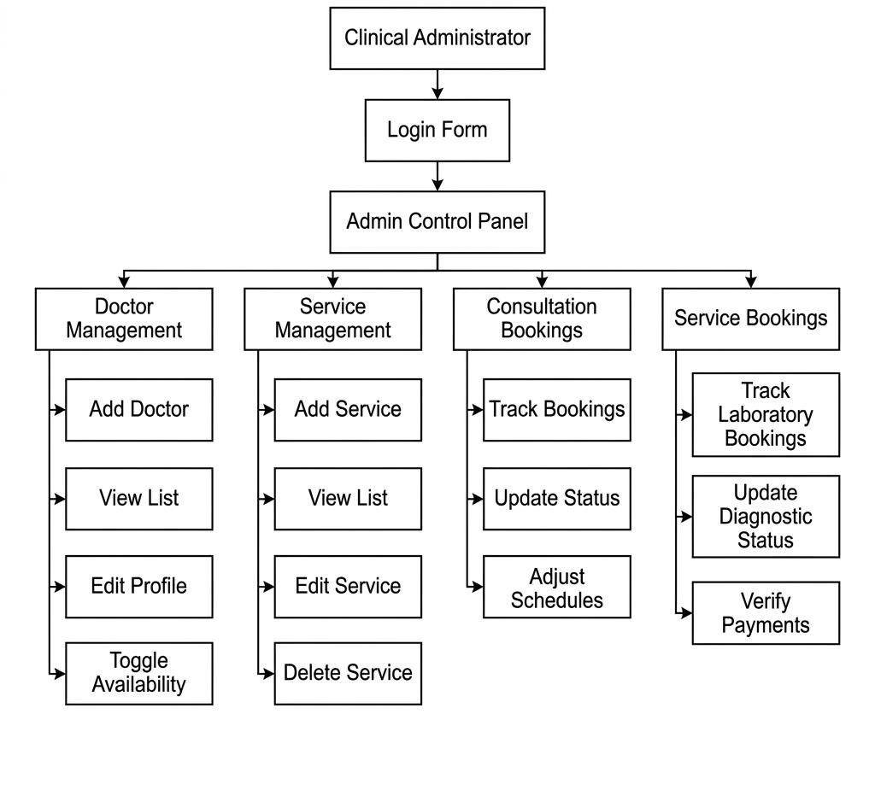

Patient/User Side :

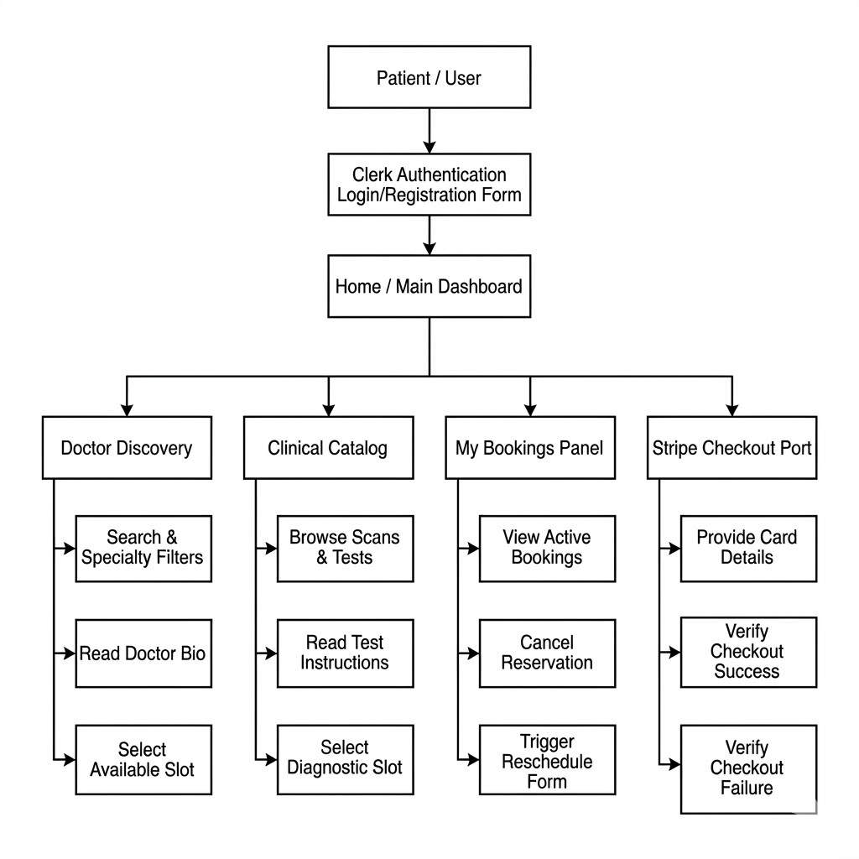

Doctor Side:
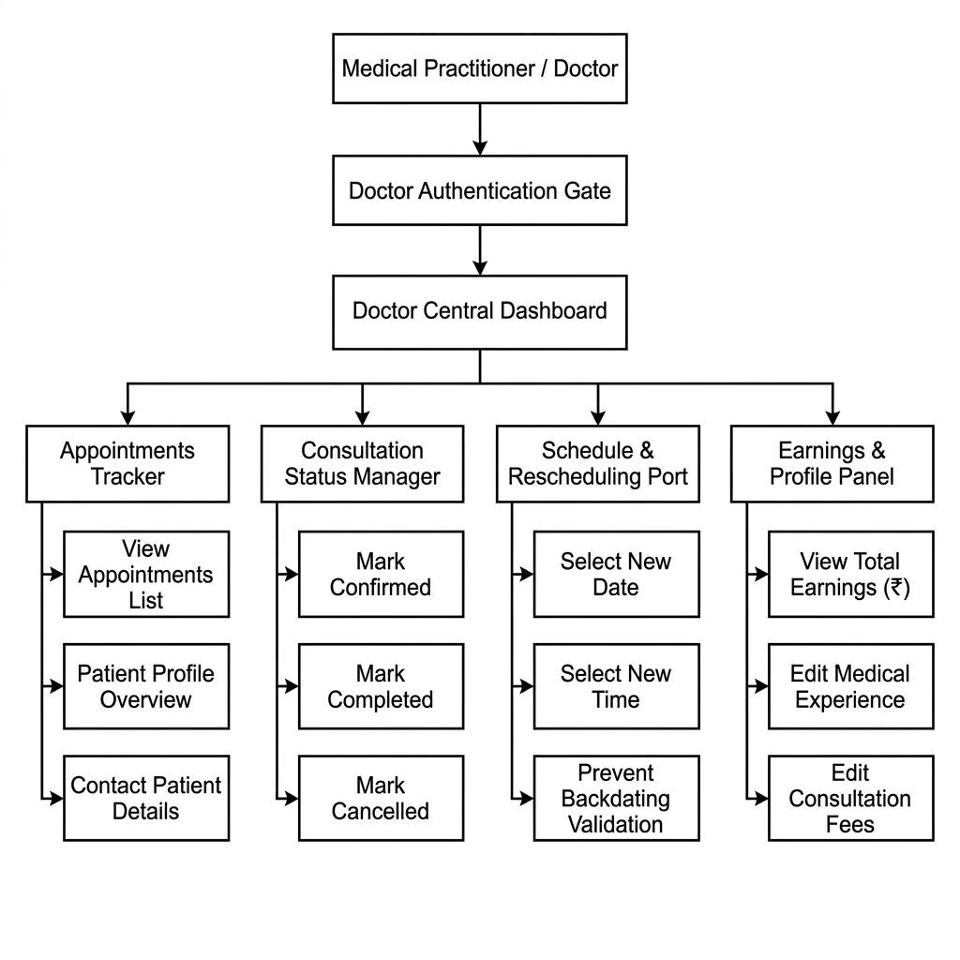

3.3.2 Functional Description of Modules
The Medi-Flow system consists of the following key functional modules:

1. Clinical Admin Module 2. Patient / User Module Admin Module
- Login: A secure login gateway where administrators can access the system using specialized administrative credentials.
- Add Doctor: Allows administrators to register a new medical specialist, entering details such as name, email, specialization, qualification, experience, consultation fee, clinic location, availability status, and a profile image.
- Manage Doctors: A catalog where administrators can view all registered doctors, edit their qualifications and fee details, toggle their availability, or remove a record.
- Add Service: Allows administrators to catalog new clinical procedures, treatments, or diagnostic scans, specifying the name, descriptions, pricing, calendar slots, pre-test instructions, and service graphics.
- Manage Services: Allows administrators to update descriptions, change pricing, and modify available laboratory testing slots.
- Track Doctor Bookings: Displays all patient appointments scheduled with medical practitioners, allowing admins to track scheduling statuses (Pending, Confirmed, Completed, Canceled).
- Track Service Bookings: A central logging panel for laboratory, therapy, or diagnostic scan reservations.
Update Booking Status: Provides controls to approve consultations, mark diagnostic tests as Completed, reschedule slot conflicts, or register cancellations.
Audit Payments: Displays the payment method (Cash-on-Arrival vs. Online Stripe payment) and tracks the transaction status (Paid, Pending, Refunded) to keep clinical books reconciled.

Patient / User Module
- Clerk Self-Registration: Allows patients to register an account using Clerk’s secure authentication widgets, verifying their email address.
- Login: Secure access powered by Clerk, supporting social sign-ins and encrypted credentials.
- Doctor Discovery: An interactive portal where patients can search for doctors and filter by medical fields (specialties) to find the right care.
- Doctor Bio & Profile: Displays detailed information about a doctor's qualifications, consultation fees, and an interactive scheduling grid displaying available time slots.
- Browse Clinical Services: Provides a clean directory of laboratory services, therapeutic sessions, and scans, showing pricing and instructions.
- Book Consultations & Services: Allows patients to select slots, enter patientspecific demographics (name, age, gender, contact number), and book appointments.
- My Bookings Dashboard: A personal panel listing all past and upcoming doctor consultations and diagnostic test appointments.
- Self-Service Cancellations & Rescheduling: Allows patients to change their appointment times or cancel bookings directly from their dashboard before their scheduled time slot.
- Stripe Online Checkout: Routes patients to a secure payment gateway page to pay online using credit cards.
- Stripe Redirect Verification: Validates transaction keys and updates the booking payment status in real-time, directing users to dynamic success or failure screens.

3.4 User Interface Design
The user interfaces for Medi-Flow are designed using React.js, Tailwind CSS, and ES6+ JavaScript, ensuring a responsive, modern layout that functions seamlessly on desktops, tablets, and mobile devices.

Technology Environment

React.js (JSX)
React.js is a component-based JavaScript library that structures user interfaces as modular, self-contained components (such as doctor search filters, time slot grids, and booking lists). React utilizes JSX (JavaScript XML), an extension that allows developers to write HTML-like structures directly inside JavaScript code. This code compiles into efficient, dynamic user interfaces, rendering page updates immediately.

Tailwind CSS
Tailwind CSS is a utility-first CSS framework used to build custom, modern layouts. Instead of using generic pre-designed UI libraries or writing bulky external stylesheets, developers apply styling utility classes directly in JSX files. This approach makes styling highly flexible and compiles a clean, optimized design system with harmonious color palettes, modern typography, responsive media layouts, and smooth micro-animations.

JavaScript (ES6+)
JavaScript is the core programming language driving the React SPA. ES6+ features (such as arrow functions, asynchronous operations, array manipulation methods, destructuring, and modular imports) power the application's runtime.
Key Advantages of JavaScript (ES6+):
- Asynchronous Fetching: Executes non-blocking API calls to Node/Express endpoints, keeping the user interface active while fetching scheduling data.
- Dynamic State Control: Coordinates client-side state hooks (useState, useEffect), instantly updating component structures as data changes.
Sanitized Client Validations: Uses regular expressions and object schemas to validate patient inputs (e.g. mobile phone, age) prior to API transmission.
Modular Code Structure: Organizes components and helper utilities into clean, reusable files, keeping the codebase easy to maintain.

List of React & JSX Elements / UI Controls:
- <div className="..."> - The core container block, styled with Tailwind for flexbox or grid layouts.
- <button className="..."> - Action components equipped with responsive hover and click states.
- <input type="text"> - Used to collect patient details, such as name and mobile number.
- <select className="..."> - Dropdown selection elements for choosing specialty fields, gender, or scheduling hours.
- <Link to="..."> - Fast, client-side routing elements that navigate between pages without reloading the web page.
- <ClerkProvider> - A top-level context provider that wraps the application to enforce authentication rules.
- <Elements> - A secure Stripe container that binds checkout forms and credit card fields safely.

4. Software Testing Introduction
Software Testing is a vital phase in the development lifecycle of Medi-Flow. It is designed to verify the correctness, completeness, security, and quality of the application. The primary objective is to detect and resolve errors before the platform goes live.
Errors occur when any system component is incomplete, inconsistent, or structurally incorrect. These issues generally fall into three categories: requirement mismatches, design discrepancies, and programming bugs (such as race conditions in bookings, database validation failures, expired auth sessions, or failed payment webhooks).

To prevent these errors, requirements are analyzed against client workflows, backend models are checked against Mongoose schemas, and the source code is tested for conformance to design specifications and user expectations.

Testing evaluates the capabilities of the system to ensure it produces the expected results. Testing is highly effective when executed systematically. Through thorough testing, the platform is verified for data consistency, user authorization security, and transaction reliability, resulting in a high-quality product, lower maintenance costs, and a smooth user experience.

4.1 Test Plan
A test plan defines the objectives, scope, strategy, and execution steps for software testing. This plan identifies the modules to be tested, the testing tasks, the roles involved, and the staging environments utilized. A well-designed test plan serves as a formal agreement between developers, quality assurance teams, and project stakeholders.
A comprehensive test plan helps external parties understand the validation methodology. Conversely, an incomplete test plan fails to evaluate critical edge cases, such as how the web app performs across different operating systems, how it handles network drops during credit card checkouts, or how it responds to concurrent booking requests on the same time slot.
Steps in Development of a Test Plan:
A structured test plan ensures systematic execution, clear error tracking, and comprehensive reporting. The test plan is built using the following key steps:

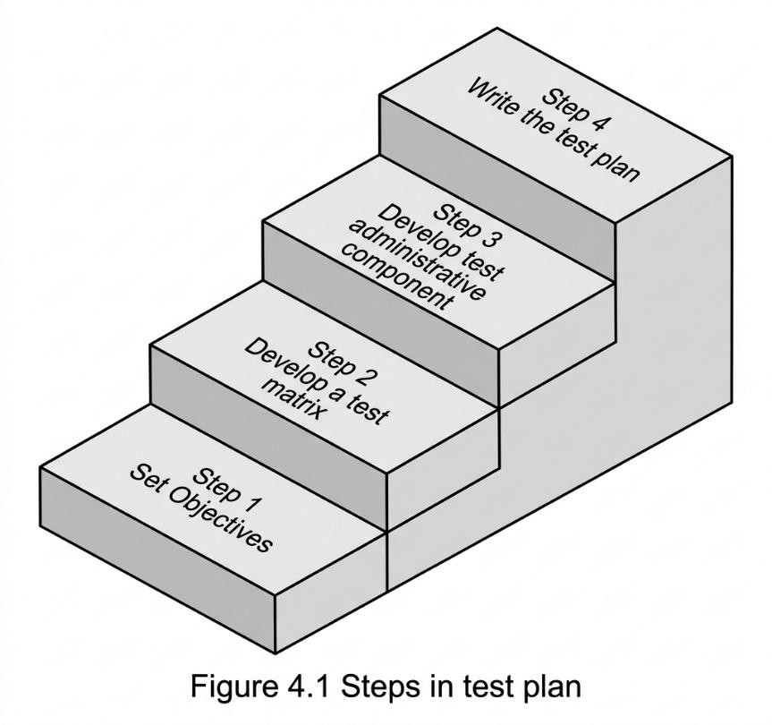
- Set Objectives of Test Plan: Before developing a test plan, it is critical to define its primary objectives. The objectives of the test plan are directly mapped to the software's functional goals. For Medi-Flow, this means verifying that patients can book available consultations without scheduling conflicts, Clerk authentication functions securely, and Stripe checkout resolves billing transactions accurately. Thus, establishing these clear operational objectives is the essential first step before drafting the testing schedules.
- Develop a Test Matrix: A test matrix represents a comprehensive layout mapping each system component (e.g. Doctor Cards, Stripe callbacks, booking slots) to the specific verification testing types required (such as Unit, Integration, or Regression tests). This matrix serves as automated verification proof, confirming that every operational feature in the platform has a corresponding test suite. Additionally, it highlights the white-box and black-box methodologies utilized across the MERN stack.
- Develop Test Administrative Component: To ensure that testing is executed efficiently, administrative parameters are defined. The administrative component of the test plan outlines the strict schedules, staging configurations (e.g. mock Atlas databases, local API hosts), and resource roles required to run the tests. However, if the development lifecycle or environment parameters change, the test plan is updated accordingly to keep resource allocations correct.
- Write the Test Plan: The individual elements—such as system objectives, verification matrices, and administrative components—are thoroughly documented. These documents are compiled into a central test plan. The compiled test plan can be structured formally or informally. In an informal structure, the team compiles the test specifications into a centralized engineering wiki, allowing testing engineers to quickly extract the exact inputs, scenarios, and endpoints required for product validation.

4.2 Test Case Design
The design of test cases is performed separately for each software unit. The general strategies defined in the master test plan are refined into component-specific testing techniques and objective evaluation criteria.
For each clinical module (e.g., appointment scheduling or payment callbacks), the test case design details the precise mock inputs, structural preconditions, execution steps, and expected outputs. By designing highly detailed unit and integration test cases, the engineering team can detect data validation issues early, significantly lowering backend maintenance costs and providing patients with a reliable, error-free booking experience.

4.3 Structure of a Test Case
To verify system behaviors systematically, each test case is designed using a standardized template. This structure ensures that testing procedures are clear, repeatable, and easy to audit during QA review sessions. The standard layout of a Medi-Flow test case contains the following operational parameters:

Parameter Field | Description / Scope
Test Case ID | A unique structural identifier (e.g. TC-  APT-01) mapping to a specific module.
Test Component | The target MERN unit or interface being evaluated (e.g. /api/appointments API endpoint).
Test Objective | A clear, concise statement describing what functional capability is being validated.
Preconditions | The required system states, login sessions, or database records before execution.
Test Inputs & Steps | The exact sequences, click actions, and API payloads executed during the test.
Expected Output | The anticipated system response, HTTP status code, or database changes.
Actual Output | The recorded behavior of the system, indicating a Pass or Fail status.

- Structure of a Test Case:
  - Transformed generic preconditions and expected results into MERNspecific contexts (e.g., verifying Clerk authentication session states, Mongoose DB schema rules, and Stripe checkout callbacks).
- Testing Strategies :
  - Grounded the testing strategy definitions (Analytic, Model-based, Methodical, Process-oriented, Dynamic, and Philosophical) inside real-world scenarios for Medi-Flow. It focuses on validating database transactions (concurrency safety for double-booking slots) and verifying high-risk endpoints (Stripe webhooks and payment gateways).
- Testing Techniques:
  - Customized Static Testing to reflect peer reviews of Mongoose database schemas (Doctor.js, Service.js, Appointment.js), React component walkthroughs, and Express API routing middleware audits.
  - Customized Dynamic Testing to encompass testing runtime behaviors across the frontend-backend communication boundary.
4.5 Different Levels of Testing
4.5.1 Black Box Testing
Black Box Testing is used to check whether the system functions correctly according to the requirements. In this testing method, the internal structure or coding of the software is not considered. It mainly focuses on checking the input and output of the system.
The following types of errors can be identified using Black Box Testing:
- Incorrect or missing functions
- Interface errors
- Errors in database structure or external database access
- Performance errors
- Initialization and termination errors
This testing ensures that every function in the developed system accepts the correct input and produces the expected output.

4.5.2 White Box Testing
White Box Testing is based on a detailed examination of the internal logic and structure of the software. It checks whether the actual output matches the expected output by testing different paths, conditions, and loops in the program.
The following test cases are generally derived in White Box Testing:
- Testing all logical conditions on both true and false sides
- Executing loops within their limits and boundaries
- Checking internal data structures for validity
- Facilitating system changes
- Simplifying integration
- Providing proper documentation
- Separating interface from implementation
White Box Testing helps improve software quality, reliability, and performance.

4.5.3 Unit Testing
Unit Testing is a testing procedure used to validate whether a particular module or unit of source code works properly. In this method, test cases are written for individual functions and methods so that any errors or regressions can be quickly identified and fixed whenever changes are made.
Benefits of Unit Testing
The main objective of Unit Testing is to isolate each part of the program and verify that every unit works correctly. It provides a clear and strict validation process for the code and offers several benefits such as:

- Helps in detecting errors early
- Improves code quality and reliability
- Simplifies debugging and maintenance
- Makes future code changes easier
- Reduces development time and cost
- Ensures each module functions independently and correctly

4.5.4 Integrated System Testing
Integrated System Testing (IST) is a systematic testing technique used to validate the overall software structure. It is mainly performed to identify errors related to the interaction between different modules or interfaces of the system.
The main objective of IST is to combine unit-tested modules and test the complete software structure designed for the system.
Integrated System Testing can be performed in two ways:
- Top-down Integration
- Bottom-up Integration
This testing helps ensure that all modules work together correctly without interface errors.
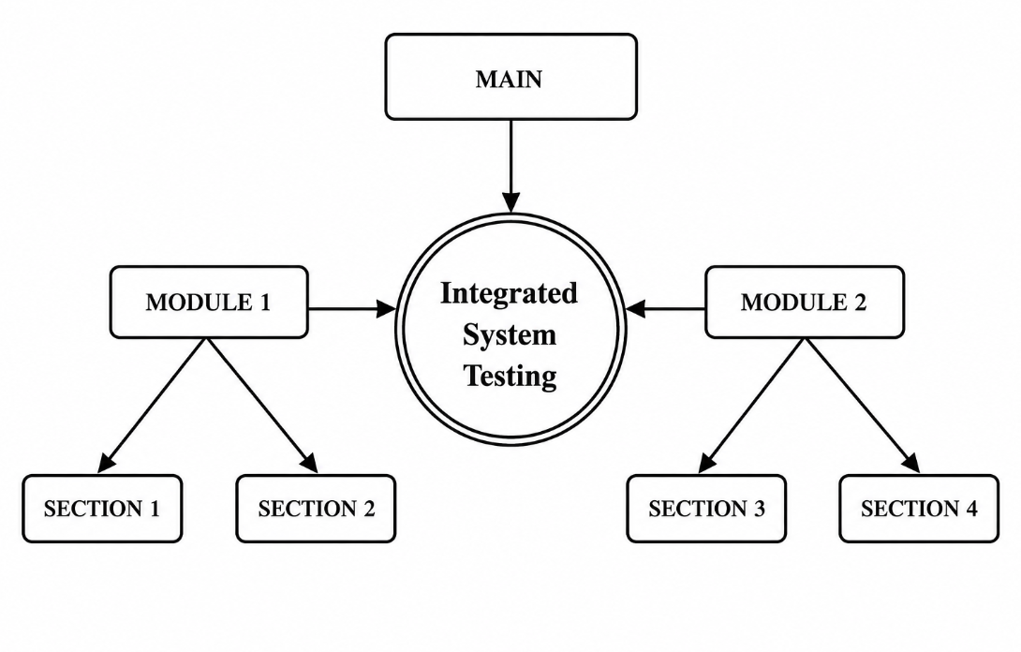

4.5.5 System Testing
System Testing is performed to test the complete software system using actual data and real-time scenarios. The main purpose of this testing is to verify whether the system works according to the client’s requirements.
System Testing generally consists of three phases:
- Alpha Testing: Testing performed by the developers.
- Beta Testing: Testing performed by selected or friendly customers.
- Acceptance Testing: Testing performed by the actual users of the system.
System Testing ensures that the complete application functions properly before deployment.

4.5.6 User Acceptance Testing
User Acceptance Testing (UAT) is performed by users or on behalf of users to ensure that the software satisfies the Business Requirement Document (BRD).
UAT mainly focuses on the following aspects:
- Verifying that all functional requirements are satisfied
- Checking whether performance requirements are achieved
- Ensuring compatibility, portability, and error recovery requirements are met
- Confirming that the acceptance criteria specified by users are satisfied
User Acceptance Testing helps confirm that the software is ready for real-world use and meets user expectations.

4.6 Software Test Report The following test cases were carried out to check the functionality of all major features of the MediFlow Hospital Management System. All the test cases were successful and passed.
Test Case Id | 1
Test Case Name | Admin Login
Test Objective | To verify that the admin login function works correctly
Pre-Conditions | Admin login portal must be accessible
Expected Result | Admin should be authenticated via Clerk/Credentials and redirected to the central dashboard
Test Action | Enter valid admin email and password and click login
Actual Result | Pass

Test Case Id | 2
Test Case Name | Add Doctor
Test Objective | To verify that a new doctor can be added with all required clinical details
Pre-Conditions | Admin must be logged in; Add Doctor form must be open
Expected Result | Doctor details should be saved to MongoDB and appear in the doctor list with Cloudinary profile image URL
Test Action | Fill in name, specialty, fee, experience, schedule, and upload profile image, then submit
Actual Result | Pass

Test Case Id | 3
Test Case Name | Edit Doctor Details
Test Objective | To verify that doctor profiles and schedules can be updated by the admin
Pre-Conditions | Admin must be logged in; doctor record must exist in the system
Expected Result | Doctor details should be updated in MongoDB and reflected in the directory immediately
Test Action | Click edit on an existing doctor, modify the consultation fee and schedule, and submit
Actual Result | Pass

Test Case Id | 4
Test Case Name | Delete Doctor Record
Test Objective | To verify that a doctor can be permanently deleted from the system
Pre-Conditions | Admin must be logged in; doctor must exist in the directory
Expected Result | Doctor should be removed from MongoDB and their Cloudinary image should be deleted
Test Action | Click delete on an existing doctor card and confirm the action
Actual Result | Pass

Test Case Id | 5
Test Case Name | Add Clinical Service
Test Objective | To verify that admin can add new medical services
Pre-Conditions | Admin must be logged in; Add Service form must be open
Expected Result | New service should be created in the database with defined pricing and duration
Test Action | Enter service name, description, category, and price, then submit
Actual Result | Pass

Test Case Id | 7
Test Case Name | Search & Filter Doctors
Test Objective | To verify that patients can filter doctors by medical specialty
Pre-Conditions | Patient must be on the main medical directory page
Expected Result | Only doctors matching the selected specialty should be displayed
Test Action | Select Cardiology from the specialty dropdown filter
Actual Result | Pass

Test Case Id | 6
Test Case Name | Patient Registration
Test Objective | To verify that a new patient can register successfully
Pre-Conditions | Registration page via Clerk must be accessible
Expected Result | New user account should be securely created and stored in the database
Test Action | Enter name, email, and password, and submit the registration form
Actual Result | Pass

Test Case Id | 7
Test Case Name | Search & Filter Doctors
Test Objective | To verify that patients can filter doctors by medical specialty
Pre-Conditions | Patient must be on the main medical directory page
Expected Result | Only doctors matching the selected specialty should be displayed
Test Action | Select Cardiology from the specialty dropdown filter
Actual Result | Pass

Test Case Id | 8
Test Case Name | Book Appointment Checkout
Test Objective | To verify that a patient can initiate an appointment booking
Pre-Conditions | Patient must be logged in; selected doctor must have available time slots
Expected Result | Patient should be redirected to the secure Stripe checkout page
Test Action | Select an available date/time slot and click Book Appointment
Actual Result | Pass

Test Case Id | 9
Test Case Name | Payment Verification
Test Objective | To verify that the system registers successful Stripe payments
Pre-Conditions | Patient must complete payment on the Stripe checkout page
Expected Result | Appointment status changes to Confirmed in MongoDB
Test Action | Complete mock transaction using Stripe test card
Actual Result | Pass

Test Case Id | 10
Test Case Name | Book Clinical Service
Test Objective | To verify that patients can book diagnostic services
Pre-Conditions | Patient must be logged in; Services page must be accessible
Expected Result | A ServiceAppointment record should be created and payment processed
Test Action | Select Blood Test, choose a date, and proceed to payment
Actual Result | Pass

Test Case Id | 11
Test Case Name | View My Appointments
Test Objective | To verify that a patient can view all their past and upcoming bookings
Pre-Conditions | Patient must be logged in and have at least one booking
Expected Result | Dashboard should display a list of all doctor and service appointments with current status
Test Action | Navigate to the My Appointments dashboard
Actual Result | Pass

Test Case Id | 12
Test Case Name | Doctor Login
Test Objective | To verify that a registered doctor can access their dedicated portal
Pre-Conditions | Doctor login page must be accessible
Expected Result | Doctor should be authenticated via JWT and redirected to their specific dashboard
Test Action | Enter valid doctor email and password and click login
Actual Result | Pass

Test Case Id | 13
Test Case Name | Toggle Availability Status
Test Objective | To verify that doctors can mark themselves Available/Unavailable
Pre-Conditions | Doctor must be logged in to their dashboard
Expected Result | Availability status updates in MongoDB; patients can no longer book if Unavailable
Test Action | Click the Toggle Availability switch on the profile page
Actual Result | Pass

Test Case Id | 14
Test Case Name | View Appointment Roster
Test Objective | To verify that doctors can view their patient schedule
Pre-Conditions | Doctor must be logged in; at least one appointment must be scheduled
Expected Result | List of patients with demographics (age, gender, time) should load
Test Action | Navigate to the Appointments tab on the doctor dashboard
Actual Result | Pass

Test Case Id | 15
Test Case Name | Update Appointment to Completed
Test Objective | To verify that a doctor can mark a consultation as finished
Pre-Conditions | Doctor must be logged in; appointment status must be Confirmed
Expected Result | Appointment status changes to Completed in the database and earnings are updated
Test Action | Select Completed from the status dropdown menu next to the patient's name
Actual Result | Pass

Test Case Id | 16
Test Case Name | Cancel Appointment (Doctor)
Test Objective | To verify that a doctor can cancel an upcoming appointment
Pre-Conditions | Doctor must be logged in; appointment status must be Pending or Confirmed
Expected Result | Appointment status changes to Cancelled
Test Action | Select Cancelled from the status dropdown menu
Actual Result | Pass

Test Case Id | 17
Test Case Name | Reschedule Appointment
Test Objective | To verify that an appointment time can be changed dynamically
Pre-Conditions | Doctor must be logged in; appointment must not be Completed
Expected Result | Date and time update in the database; status changes to Rescheduled
Test Action | Click Reschedule, select a new date and time, and save
Actual Result | Pass

Test Case Id | 18
Test Case Name | View Central Metrics Dashboard
Test Objective | To verify that Admin dashboard aggregates data correctly
Pre-Conditions | Admin must be logged in
Expected Result | Total Doctors, Registered Users, Total Earnings, and Appointment stats display accurately
Test Action | Navigate to the main Admin Dashboard overview
Actual Result | Pass

Test Case Id | 19
Test Case Name | CORS Policy & API Access
Test Objective | To verify that backend securely accepts requests only from allowed frontends
Pre-Conditions | Backend server must be running
Expected Result | Requests from unapproved origins should be blocked by CORS policy
Test Action | Send a direct API fetch request from an unauthorized local port
Actual Result | Pass

Test Case Id | 20
Test Case Name | Logout
Test Objective | To verify that the logout function terminates the session correctly
Pre-Conditions | User (Admin, Doctor, or Patient) must be logged in
Expected Result | JWT token/Clerk session should be cleared and user redirected to homepage
Test Action | Click the Logout or Sign Out button in the navigation menu
Actual Result | Pass

5. CONCLUSION AND FUTURE SCOPE
Conclusion: The MediFlow Hospital Management System has been developed and thoroughly tested. The software requirements specification documents were used to validate the product, and it meets all the functional requirements and project objectives. The system was rigorously tested for bugs and network errors, and all identified issues have been resolved, ensuring a stable, fault-free deployment.
The key features of the system include:
- The system is highly intuitive and provides separate, dedicated portals for Administrators, Doctors, and Patients, allowing each user to access only the features strictly relevant to their role.
- MongoDB Atlas has replaced outdated paper-based scheduling. All critical records—such as doctor profiles, patient demographics, clinical service details, and appointment histories—are securely stored in a scalable cloud database.
- Financial transactions are fully automated via secure Stripe integration. This ensures real-time payment verification for both doctor consultations and diagnostic services, eliminating manual payment disputes.
- Secure access is guaranteed through robust Clerk OAuth for patients and custom JWT-based authentication (with bcrypt hashing) for doctors and administrators. Strict role-based middleware ensures authorized access across all routes.
- The admin can monitor vital hospital metrics—including total registered doctors, active users, completed appointments, and total generated earnings—in real-time from a centralized Central Metrics Dashboard.
- Patients can browse the medical directory, filter specialists by clinical category, view interactive availability grids, and securely book and monitor their appointments from any device via a responsive web interface.
Future Scope: The MediFlow Hospital Management System provides a strong foundation and can be further enhanced in the future by adding more features and improvements such as:
- Native Mobile Application: A dedicated application for Android and iOS could be developed using React Native, providing patients and medical staff with a seamless native experience on their smartphones.
- Automated Reminder System: An automated SMS or email notification service (via Twilio or Nodemailer) could be added to alert patients 24 hours before their scheduled appointment, significantly minimizing clinical "no-shows".
- Electronic Health Records (EHR): The system could be expanded to allow doctors to upload and attach digital prescriptions, diagnostic lab reports, and consultation notes directly to a patient's digital profile.
- Integrated Telemedicine: A secure video consultation feature could be integrated using WebRTC, enabling doctors to conduct remote virtual check-ups directly through the MediFlow platform.

